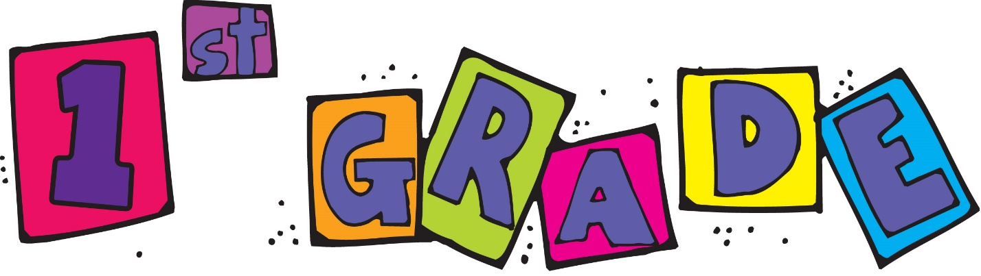

3 vinyl pocket folders (with 2 pockets)
2 boxes of 24 crayons
1 pkg. thin Expo Dry Erase Markers
(The brand Expo is important, as other stain our
boards.)
4 large glue sticks
1 box #2 pencils sharpened
1 large zipper pencil case (no pencil boxes please)
2 large boxes of facial tissues
1 packages wet wipes
1 backpack (no wheels)

Please label all materials and have your child bring them to school on the first day.

Thank you!

