April 20, 2020
OBJECTIVE: How do people help each other?
SWBAT:
*Use word structure to determine word meaning.
*read fiction and or nonfiction and complete a reading response prompt.
*practice writing in complete sentences, revising and editing.
STANDARD(S):
W.4.10. Write routinely over extended time frames (time for research, reflection, metacognition/self-correction and revision) and shorter time frames (a single sitting or a day or two for a range of discipline-specific tasks, purposes, and audiences.
RL.4.10. By the end of the year, read and comprehend literature, including stories, dramas, and poems at grade level text-complexity or above, with scaffolding as needed.
RF.4.4: Read with sufficient accuracy and fluency to support comprehension.
L.4.1: Demonstrate command of the conventions of standard English grammar and usage when writing or speaking.
RL: 5.1, 5.2
RF: 5.3, 5.4
W.5.9
WIDA 2,4: The Language of Language Arts, The Language of Social Studies
TIME FRAME: 20 minutes
Activity Directions:
Students will identify the following vocabulary words:
- Action 2. gift 3. receive 4. difference 5. problem 6. solution
Students will use google translate to:
~ Listen & repeat word 3 times
~ Write definition and a sentence for each vocabulary word either in your notebook or send a Word document to your ESL teacher in TEAMS.
Learning Materials: Google translate, Reach Level D ~ Teacher’s Edition
Assessment: WIDA Writing Rubric

April 21, 2020
OBJECTIVE:
* use word structure to determine word meaning.
*read fiction and or nonfiction and complete a reading response prompt.
*practice writing in complete sentences, revising and editing.
STANDARD(S):

W.4.10. Write routinely over extended time frames (time for research, reflection, metacognition/self-correction and revision) and shorter time frames (a single sitting or a day or two for a range of discipline-specific tasks, purposes, and audiences.
RL.4.10. By the end of the year, read and comprehend literature, including stories, dramas, and poems at grade level text-complexity or above, with scaffolding as needed.
RF.4.4: Read with sufficient accuracy and fluency to support comprehension.
L.4.1: Demonstrate command of the conventions of standard English grammar and usage when writing or speaking.
RL: 5.1, 5.2
RF: 5.3, 5.4
W.5.9

WIDA 2, 4: The Language of Language Arts, The Language of Mathematics

TIME FRAME: 20 Minutes.

Activity Directions: Students will listen to a read aloud of “Those Shoes”.

Students will practice reading skills. Students will identify ways people help each other. Write a paragraph answering the prompt: How can one act of kindness make a difference?
Write your answer in your notebook or send a Word document to your ESL teacher in TEAMS.

Learning Materials: Reach Level D, Google translate as needed.
Assessment: WIDA Writing Rubric

April 22, 2020
OBJECTIVE: SWBAT: Students practice reading skills.
* use word structure to determine word meaning.
*read fiction and or nonfiction and complete a reading response prompt.
*practice writing in complete sentences, revising and editing.

STANDARD(S):
W.4.10. Write routinely over extended time frames (time for research, reflection, metacognition/self-correction and revision) and shorter time frames (a single sitting or a day or two for a range of discipline-specific tasks, purposes, and audiences.
RL.4.10. By the end of the year, read and comprehend literature, including stories, dramas, and poems at grade level text-complexity or above, with scaffolding as needed.
RF.4.4: Read with sufficient accuracy and fluency to support comprehension.
L.4.1: Demonstrate command of the conventions of standard English grammar and usage when writing or speaking.
RL: 5.1, 5.2
RF: 5.3, 5.4
W.5.9

WIDA 2: The Language of Language Arts

TIME FRAME: 20 minutes
__________________________________________________________________________________
Activity Directions: Students use Reach textbook page 26.
Students build comprehension skills. Students answer questions #1-3. Students write complete sentences using proper capitalization, spelling & punctuation.
Write your answer in your notebook or send a Word document to your ESL teacher in TEAMS.

Learning Materials: Google translate as needed.

Assessment: WIDA Writing Rubric

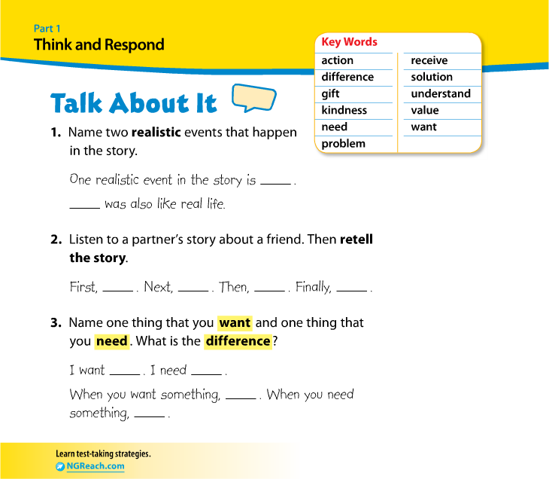

Garfield Public Schools
Remote Learning Lesson Plans
Grade 4th and 5th - ESL

April 23,2020
OBJECTIVE: Students use sequence words: first, then, next & finally.
SWBAT:
*Use word structure to determine word meaning.
STANDARD(S):
W.4.10. Write routinely over extended time frames (time for research, reflection, metacognition/self-correction and revision) and shorter time frames (a single sitting or a day or two for a range of discipline-specific tasks, purposes, and audiences.
RL.4.10. By the end of the year, read and comprehend literature, including stories, dramas, and poems at grade level text-complexity or above, with scaffolding as needed.
RF.4.4: Read with sufficient accuracy and fluency to support comprehension.
L.4.1: Demonstrate command of the conventions of standard English grammar and usage when writing or speaking.
RL: 5.1, 5.2
RF: 5.3, 5.4
W.5.9
WIDA 1,2: Social & Instructional Language, The Language of Language Arts
TIME FRAME: 20 minutes
Activity Directions:
Students retell story “Those Shoes”. Students write 3 paragraphs to summarize story including beginning, middle & end.
Write your answer in your notebook or send a Word document to your ESL teacher in TEAMS.

Learning Materials: Google translate, Reach book

Assessment: WIDA Writing Rubric

April 24, 2020
OBJECTIVE: Practice fluency skills
* use word structure to determine word meaning.
*read fiction and or nonfiction and complete a reading response prompt.
STANDARD(S):

W.4.10. Write routinely over extended time frames (time for research, reflection, metacognition/self-correction and revision) and shorter time frames (a single sitting or a day or two for a range of discipline-specific tasks, purposes, and audiences.
RL.4.10. By the end of the year, read and comprehend literature, including stories, dramas, and poems at grade level text-complexity or above, with scaffolding as needed.
RF.4.4: Read with sufficient accuracy and fluency to support comprehension.
L.4.1: Demonstrate command of the conventions of standard English grammar and usage when writing or speaking.
RL: 5.1, 5.2
RF: 5.3, 5.4
W.5.9

WIDA 2: The Language of Language Arts

TIME FRAME: 20 Minutes.

Activity Directions: Students will read poem “Guardian Angel”.
Students will write & answer question:
How does the girl in this poem show kindness?
What are some examples of how you can show kindness to others?

Write your answer in your notebook or send a Word document to your ESL teacher in TEAMS.

Learning Materials: Google translate if needed. Reach Level D- Volume 1
Assessment: WIDA Writing Rubric

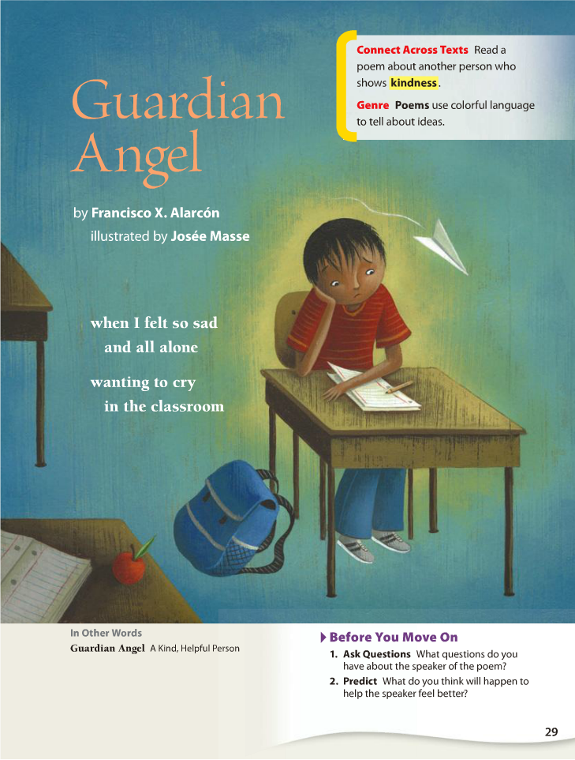

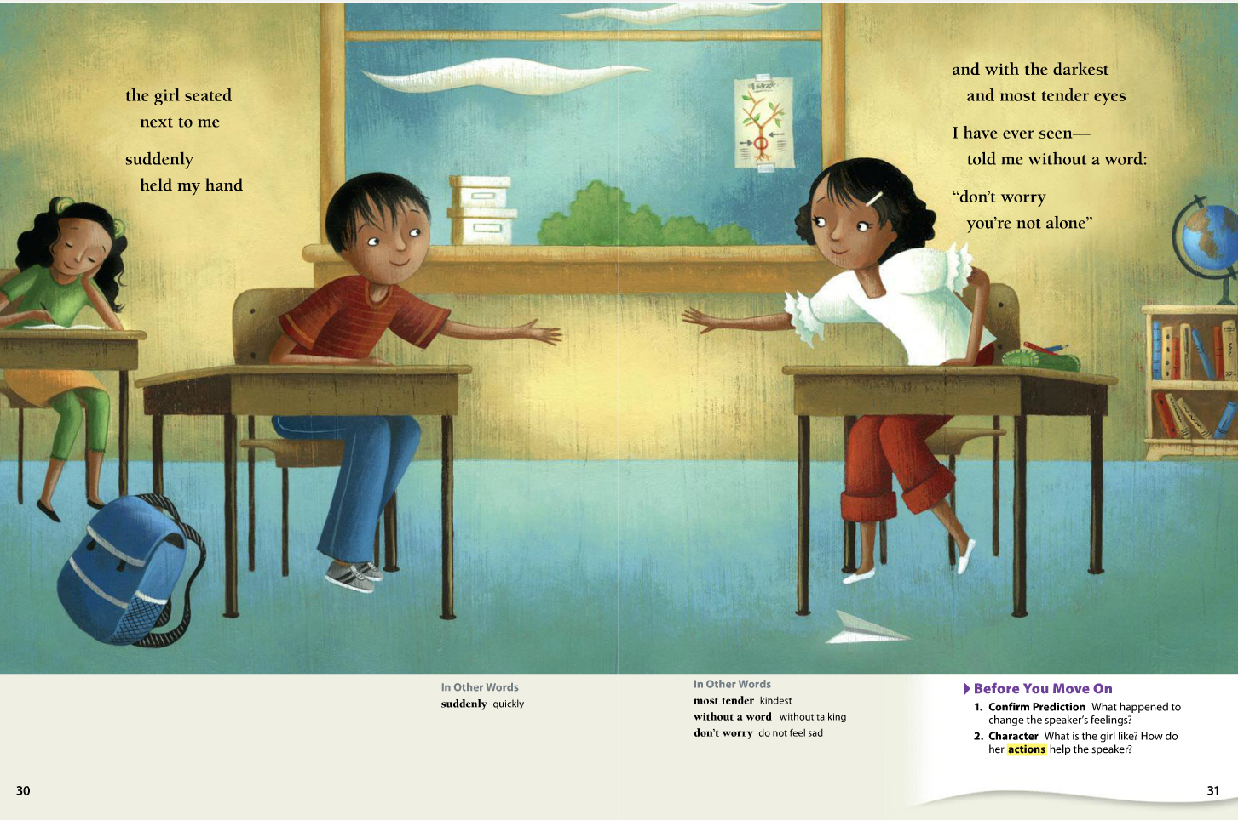

April 27, 2020
OBJECTIVE: How do people help each other?
SWBAT:
*Use word structure to determine word meaning.
*read fiction and or nonfiction and complete a reading response prompt.
*practice writing in complete sentences, revising and editing.

STANDARD(S):
W.4.10. Write routinely over extended time frames (time for research, reflection, metacognition/self-correction and revision) and shorter time frames (a single sitting or a day or two for a range of discipline-specific tasks, purposes, and audiences.
RL.4.10. By the end of the year, read and comprehend literature, including stories, dramas, and poems at grade level text-complexity or above, with scaffolding as needed.
RF.4.4: Read with sufficient accuracy and fluency to support comprehension.
L.4.1: Demonstrate command of the conventions of standard English grammar and usage when writing or speaking.
RL: 5.1, 5.2
RF: 5.3, 5.4
W.5.9
WIDA 2,4: The Language of Language Arts, The Language of Social Studies
TIME FRAME: 20 minutes
Activity Directions:

Students will identify the following vocabulary words:
1.Neighborhood 2. Individual 3. Volunteer 4. Comparison 5. Monitor 6. Benefit

Students will use google translate to:
~ Listen & repeat word 3 times
~ Write your answer in your notebook or send a Word document to your ESL teacher in TEAMS.

Learning Materials: Google translate, Reach Level D ~ Teacher’s Edition
Assessment: WIDA Writing Rubric

April 28, 2020
OBJECTIVE: How do people help each other?
* use word structure to determine word meaning.
*read fiction and or nonfiction and complete a reading response prompt.
*practice writing in complete sentences, revising and editing.
STANDARD(S):

W.4.10. Write routinely over extended time frames (time for research, reflection, metacognition/self-correction and revision) and shorter time frames (a single sitting or a day or two for a range of discipline-specific tasks, purposes, and audiences.
RL.4.10. By the end of the year, read and comprehend literature, including stories, dramas, and poems at grade level text-complexity or above, with scaffolding as needed.
RF.4.4: Read with sufficient accuracy and fluency to support comprehension.
L.4.1: Demonstrate command of the conventions of standard English grammar and usage when writing or speaking.
RL: 5.1, 5.2
RF: 5.3, 5.4
W.5.9

WIDA 2, 4: The Language of Language Arts, The Language of Mathematics

TIME FRAME: 20 Minutes.

Activity Directions: Students will listen to a read aloud of the autobiography “The World’s Greatest Underachiever”.

Students will practice reading skills. Students will identify ways people help each other. What did you learn from this story? Write your answer in your notebook or send a Word document to your ESL teacher in TEAMS.

Learning Materials: Reach Level D, Google translate as needed.
Assessment: WIDA Writing Rubric

April 29, 2020
OBJECTIVE: SWBAT: How do people help each other?
* use word structure to determine word meaning.
*read fiction and or nonfiction and complete a reading response prompt.
*practice writing in complete sentences, revising and editing.

STANDARD(S):
W.4.10. Write routinely over extended time frames (time for research, reflection, metacognition/self-correction and revision) and shorter time frames (a single sitting or a day or two for a range of discipline-specific tasks, purposes, and audiences.
RL.4.10. By the end of the year, read and comprehend literature, including stories, dramas, and poems at grade level text-complexity or above, with scaffolding as needed.
RF.4.4: Read with sufficient accuracy and fluency to support comprehension.
L.4.1: Demonstrate command of the conventions of standard English grammar and usage when writing or speaking.
RL: 5.1, 5.2
RF: 5.3, 5.4
W.5.9

WIDA 2: The Language of Language Arts

TIME FRAME: 20 minutes
__________________________________________________________________________________
Activity Directions:
Students build comprehension skills. Students answer questions #1-3. Students write complete sentences using proper capitalization, spelling & punctuation. Write your answer in your notebook or send a Word document to your ESL teacher in TEAMS.

Learning Materials: Google translate as needed.

Assessment: WIDA Writing Rubric

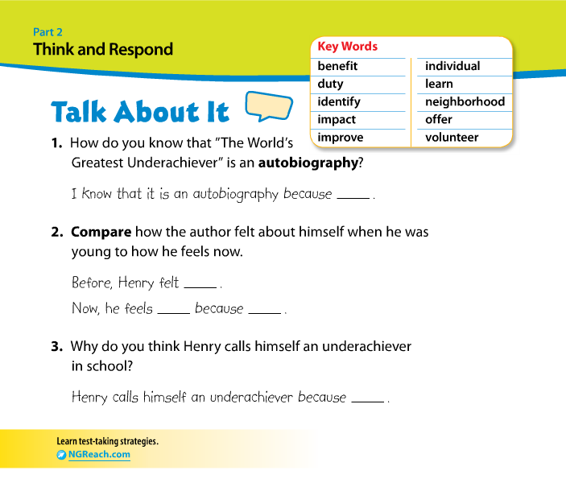

Garfield Public Schools
Remote Learning Lesson Plans
Grade 4th and 5th - ESL

April 30, 2020
OBJECTIVE: Students identify ways people help each other?
SWBAT:
*Use word structure to determine word meaning.
STANDARD(S):
W.4.10. Write routinely over extended time frames (time for research, reflection, metacognition/self-correction and revision) and shorter time frames (a single sitting or a day or two for a range of discipline-specific tasks, purposes, and audiences.
RL.4.10. By the end of the year, read and comprehend literature, including stories, dramas, and poems at grade level text-complexity or above, with scaffolding as needed.
RF.4.4: Read with sufficient accuracy and fluency to support comprehension.
L.4.1: Demonstrate command of the conventions of standard English grammar and usage when writing or speaking.
RL: 5.1, 5.2
RF: 5.3, 5.4
W.5.9
WIDA 1,2: Social & Instructional Language, The Language of Language Arts
TIME FRAME: 20 minutes
Activity Directions:
Students write an autobiography about themselves or their favorite person.
Please include name, age, birthdate, birth place, languages spoken, favorite place, etc. Please write 3 paragraphs: remember to use proper punctuation, spelling & capitalization.

Write your answer in your notebook or send a Word document to your ESL teacher in TEAMS.
Learning Materials: Google translate, Reach book

Assessment: WIDA Writing Rubric

May 1, 2020
OBJECTIVE: Practice fluency skills
* use word structure to determine word meaning.
*read fiction and or nonfiction and complete a reading response prompt.
STANDARD(S):

W.4.10. Write routinely over extended time frames (time for research, reflection, metacognition/self-correction and revision) and shorter time frames (a single sitting or a day or two for a range of discipline-specific tasks, purposes, and audiences.
RL.4.10. By the end of the year, read and comprehend literature, including stories, dramas, and poems at grade level text-complexity or above, with scaffolding as needed.
RF.4.4: Read with sufficient accuracy and fluency to support comprehension.
L.4.1: Demonstrate command of the conventions of standard English grammar and usage when writing or speaking.
RL: 5.1, 5.2
RF: 5.3, 5.4
W.5.9

WIDA 2: The Language of Language Arts

TIME FRAME: 20 Minutes.

Activity Directions: Students will read biography “Making A Difference”.
Please read pages 57-61.
Students will write & answer question:
How can your family help in your community? Please
use some new vocabulary words: neighborhood, volunteer, individual,
Benefit & monitor in your paragraph.

Write your answer in your notebook or send a Word document to your ESL teacher in TEAMS.
Learning Materials: Google translate if needed. Reach Level D- Volume 1
Assessment: WIDA Writing Rubric

