Garfield Public Schools
Remote Learning
Lesson Plans
“Grade 1 – ESL”
DAY # 21

OBJECTIVE
- Students will be able to read or listen to and answer comprehension questions about a nonfiction story on turtles.
- Students will be able to produce sentences using learned vocabulary words

STANDARD(S):
WIDA 2: The Language of Language Arts
WIDA 4: The Language of Science
RI.1.1 RF.1.3 W.1.2
TIME FRAME:
60 min. (Assignment to be carried out over three (3) days)
ACTIVITY:
- Go to EPIC and read: Turtles: Backyard Wildlife
https://www.getepic.com/app/read/6513
- Take quiz.
- Go back to p.22 of story and read the vocabulary words and their meanings.
- Use each vocabulary word from p. 22 in a sentence and write it in a notebook or on paper.
- Draw a turtle with spots and patterns on its scales. Write three (3) sentences about your turtle.

Differentiation Strategies for Remote Learning
Access to Google Translate; bilingual dictionaries; teacher’s email for clarification
Beginning Level: communicate through drawings
Intermediate Level: form simple sentences using word banks
Advanced Level: produce original sentences

*ATTACH PAPER-BASED ASSIGNMENTS WITH EACH LESSON PLAN
*FOR DIGITAL ACTIVITIES, INCLUDE WEBSITES AND LOG-IN INFORMATION.

Garfield Public Schools
Remote Learning
Lesson Plans
“Grade 1 – ESL”
DAY # 22

OBJECTIVE
- Students will be able to read or listen to and answer comprehension questions about a nonfiction story on turtles.
- Students will be able to produce sentences using learned vocabulary words

STANDARD(S):
WIDA 2: The Language of Language Arts
WIDA 4: The Language of Science
RI.1.1 RF.1.3 W.1.2
TIME FRAME:
60 min. (Assignment to be carried out over three (3) days)
ACTIVITY:
- Go to EPIC and read: Turtles: Backyard Wildlife
https://www.getepic.com/app/read/6513
- Take quiz.
- Go back to p.22 of story and read the vocabulary words and their meanings.
- Use each vocabulary word from p. 22 in a sentence and write it in a notebook or on paper.
- Draw a turtle with spots and patterns on its scales. Write three (3) sentences about your turtle.

Differentiation Strategies for Remote Learning
Access to Google Translate; bilingual dictionaries; teacher’s email for clarification
Beginning Level: communicate through drawings
Intermediate Level: form simple sentences using word banks
Advanced Level: produce original sentences

*ATTACH PAPER-BASED ASSIGNMENTS WITH EACH LESSON PLAN
*FOR DIGITAL ACTIVITIES, INCLUDE WEBSITES AND LOG-IN INFORMATION.

Garfield Public Schools
Remote Learning
Lesson Plans
“Grade 1 – ESL”
DAY # 23

OBJECTIVE
- Students will be able to read or listen to and answer comprehension questions about a nonfiction story on turtles.
- Students will be able to produce sentences using learned vocabulary words

STANDARD(S):
WIDA 2: The Language of Language Arts
WIDA 4: The Language of Science
RI.1.1 RF.1.3 W.1.2
TIME FRAME:
60 min. (Assignment to be carried out over three (3) days)
ACTIVITY:
- Go to EPIC and read: Turtles: Backyard Wildlife
https://www.getepic.com/app/read/6513
- Take quiz.
- Go back to p.22 of story and read the vocabulary words and their meanings.
- Use each vocabulary word from p. 22 in a sentence and write it in a notebook or on paper.
- Draw a turtle with spots and patterns on its scales. Write three (3) sentences about your turtle.

Differentiation Strategies for Remote Learning
Access to Google Translate; bilingual dictionaries; teacher’s email for clarification
Beginning Level: communicate through drawings
Intermediate Level: form simple sentences using word banks
Advanced Level: produce original sentences

*ATTACH PAPER-BASED ASSIGNMENTS WITH EACH LESSON PLAN
*FOR DIGITAL ACTIVITIES, INCLUDE WEBSITES AND LOG-IN INFORMATION.

Garfield Public Schools
Remote Learning
Lesson Plans
“Grade 1 – ESL”
DAY # 24

OBJECTIVE
- Students will be able to read or listen to and answer comprehension questions about a nonfiction story on turtles.
- Students will be able to produce sentences using learned vocabulary words
STANDARD(S):
WIDA 2: The Language of Language Arts
WIDA 4: The Language of Science
RI.1.1 RF.1.3 W.1.2
TIME FRAME:
60 min. (Assignment to be carried out over three (3) days)
ACTIVITY:
- Go to bookflix.com and read: World of Insects: Butterflies
https://bookflix.digital.scholastic.com/pair/detail/bk0072pr/book?authCtx=U.600199892

If needed, use the following:
Username: capplelane
Password: bookflix

- After reading the story, click on “Word Match” on the left and choose your answers.
- Next, click on “Which Came First?” and put the sentences in order
- Use the following words from the story in a sentence and write it in a notebook or on paper:
insects / hatch / chrysalis / narrow / nectar
- Draw a picture of your colorful butterfly on a leaf. Write three (3) sentences about your beautiful butterfly.

Differentiation Strategies for Remote Learning
Access to Google Translate; bilingual dictionaries; teacher’s email for clarification
Beginning Level: communicate through drawings
Intermediate Level: form simple sentences using word banks
Advanced Level: produce original sentences

*ATTACH PAPER-BASED ASSIGNMENTS WITH EACH LESSON PLAN
*FOR DIGITAL ACTIVITIES, INCLUDE WEBSITES AND LOG-IN INFORMATION.
Garfield Public Schools
Remote Learning
Lesson Plans
“Grade 1 – ESL”
DAY # 25

OBJECTIVE
- Students will be able to read or listen to and answer comprehension questions about a nonfiction story on turtles.
- Students will be able to produce sentences using learned vocabulary words
STANDARD(S):
WIDA 2: The Language of Language Arts
WIDA 4: The Language of Science
RI.1.1 RF.1.3 W.1.2
TIME FRAME:
60 min. (Assignment to be carried out over three (3) days)
ACTIVITY:
- Go to bookflix.com and read: World of Insects: Butterflies
https://bookflix.digital.scholastic.com/pair/detail/bk0072pr/book?authCtx=U.600199892

If needed, use the following:
Username: capplelane
Password: bookflix

- After reading the story, click on “Word Match” on the left and choose your answers.
- Next, click on “Which Came First?” and put the sentences in order
- Use the following words from the story in a sentence and write it in a notebook or on paper:
insects / hatch / chrysalis / narrow / nectar
- Draw a picture of your colorful butterfly on a leaf. Write three (3) sentences about your beautiful butterfly.

Differentiation Strategies for Remote Learning
Access to Google Translate; bilingual dictionaries; teacher’s email for clarification
Beginning Level: communicate through drawings
Intermediate Level: form simple sentences using word banks
Advanced Level: produce original sentences

*ATTACH PAPER-BASED ASSIGNMENTS WITH EACH LESSON PLAN
*FOR DIGITAL ACTIVITIES, INCLUDE WEBSITES AND LOG-IN INFORMATION.
Garfield Public Schools
Remote Learning
Lesson Plans
“Grade 1 – ESL”
DAY # 26

OBJECTIVE
- Students will be able to read or listen to and answer comprehension questions about a nonfiction story on turtles.
- Students will be able to produce sentences using learned vocabulary words
STANDARD(S):
WIDA 2: The Language of Language Arts
WIDA 4: The Language of Science
RI.1.1 RF.1.3 W.1.2
TIME FRAME:
60 min. (Assignment to be carried out over three (3) days)
ACTIVITY:
- Go to bookflix.com and read: World of Insects: Butterflies
https://bookflix.digital.scholastic.com/pair/detail/bk0072pr/book?authCtx=U.600199892

If needed, use the following:
Username: capplelane
Password: bookflix
- After reading the story, click on “Word Match” on the left and choose your answers.
- Next, click on “Which Came First?” and put the sentences in order
- Use the following words from the story in a sentence and write it in a notebook or on paper:
insects / hatch / chrysalis / narrow / nectar
- Draw a picture of your colorful butterfly on a leaf. Write three (3) sentences about your beautiful butterfly.

Differentiation Strategies for Remote Learning
Access to Google Translate; bilingual dictionaries; teacher’s email for clarification
Beginning Level: communicate through drawings
Intermediate Level: form simple sentences using word banks
Advanced Level: produce original sentences

*ATTACH PAPER-BASED ASSIGNMENTS WITH EACH LESSON PLAN
*FOR DIGITAL ACTIVITIES, INCLUDE WEBSITES AND LOG-IN INFORMATION.
Garfield Public Schools
Remote Learning
Lesson Plans
“Grade 1 – ESL”
DAY # 27
OBJECTIVE
- Students will be able to compare and contrast the turtle and the butterfly using a Venn Diagram.
STANDARD(S):
WIDA 2: The Language of Language Arts
WIDA 4: The Language of Science
W.1.2 RI.1.1
TIME FRAME:
40 min. (Assignment to be carried out over two (2) days)
ACTIVITY:

Using the information you read from the stories – Turtles: Backyard Wildlife and
World of Insects: Butterflies, think about the following questions:

- How is a butterfly different from a turtle? Write each difference under “The Butterfly” in the Venn Diagram.

- How is a turtle different from a butterfly? Write each difference under “Turtle” in the Venn Diagram.

- How are they both the same? Write these answers under “Both” in the Venn Diagram.

- Which of the two is your favorite, the butterfly or the turtle? Write three (3) sentences saying why you like it best.

Differentiation Strategies for Remote Learning
Access to Google Translate; bilingual dictionaries; teacher’s email for clarification
Beginning Level: communicate through drawings
Intermediate Level: form simple sentences using word banks
Advanced Level: produce original sentences
*ATTACH PAPER-BASED ASSIGNMENTS WITH EACH LESSON PLAN
*FOR DIGITAL ACTIVITIES, INCLUDE WEBSITES AND LOG-IN INFORMATION.

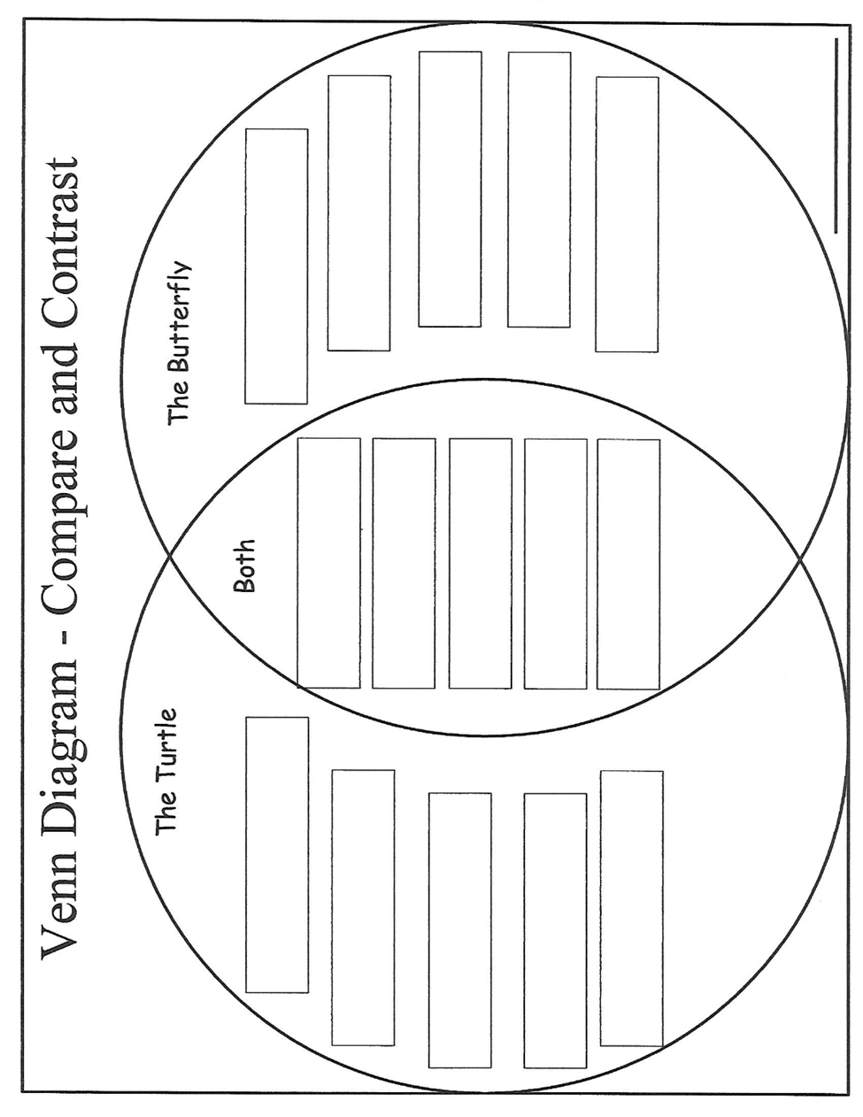
Garfield Public Schools
Remote Learning
Lesson Plans
“Grade 1 – ESL”
DAY # 28

OBJECTIVE
- Students will be able to compare and contrast the turtle and the butterfly using a Venn Diagram.
STANDARD(S):
WIDA 2: The Language of Language Arts
WIDA 4: The Language of Science
W.1.2 RI.1.1
TIME FRAME:
40 min. (Assignment to be carried out over two (2) days)
ACTIVITY:

Using the information you read from the stories – Turtles: Backyard Wildlife and
World of Insects: Butterflies, think about the following questions:

- How is a butterfly different from a turtle? Write each difference under “The Butterfly” in the Venn Diagram.

- How is a turtle different from a butterfly? Write each difference under “Turtle” in the Venn Diagram.

- How are they both the same? Write these answers under “Both” in the Venn Diagram.

- Which of the two is your favorite, the butterfly or the turtle? Write three (3) sentences saying why you like it best.

Differentiation Strategies for Remote Learning
Access to Google Translate; bilingual dictionaries; teacher’s email for clarification
Beginning Level: communicate through drawings
Intermediate Level: form simple sentences using word banks
Advanced Level: produce original sentences
*ATTACH PAPER-BASED ASSIGNMENTS WITH EACH LESSON PLAN
*FOR DIGITAL ACTIVITIES, INCLUDE WEBSITES AND LOG-IN INFORMATION.

Garfield Public Schools
Remote Learning
Lesson Plans
“Grade 1 – ESL”
DAY # 29
OBJECTIVE
- Students will be able to read key vocabulary words about animal parts and coverings.
- Students will be able to produce sentences using key vocabulary words.
- Students will be able to use a concept map to show how animals are different.
STANDARD(S):
WIDA 2 – The Language of Language Arts
WIDA 4 - The Language of Science
RI.1.6 W.1.2
TIME FRAME:
40 min. (Assignment to be carried out over two (2) days)
ACTIVITY:
- Go to YouTube.com and watch the video: Animal Body Parts
https://www.youtube.com/watch?v=szEzGwsdwmg
- Read the Key Words on page 11.
- Use each Key Word in a sentence to tell about the flamingo, the alligator, and
the tiger.
Example: The flamingo has a beak.
- Look at p. 12. How are animals different? Write your answers in the circles.

Differentiation Strategies for Remote Learning
Access to Google Translate; bilingual dictionaries; teacher’s email for clarification
Beginning Level: communicate through drawings
Intermediate Level: form simple sentences using word banks
Advanced Level: produce original sentences

*ATTACH PAPER-BASED ASSIGNMENTS WITH EACH LESSON PLAN
*FOR DIGITAL ACTIVITIES, INCLUDE WEBSITES AND LOG-IN INFORMATION.

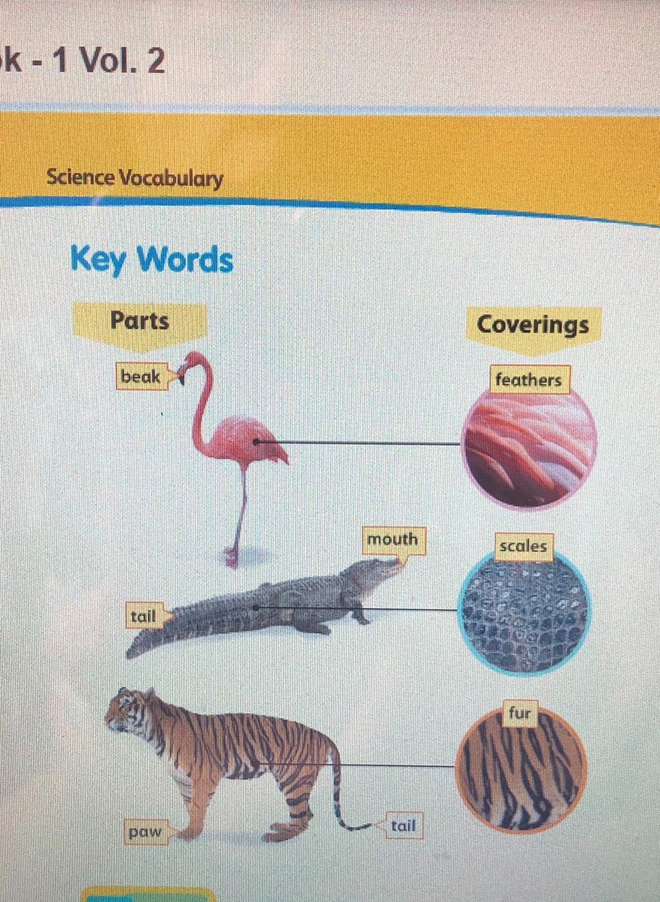
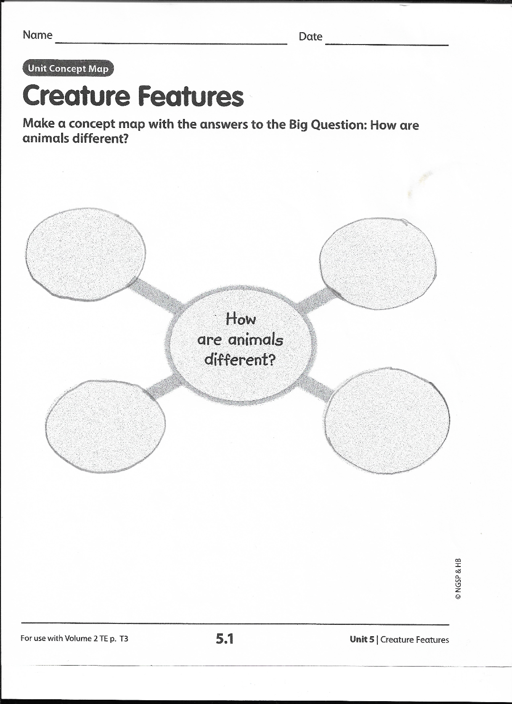

Garfield Public Schools
Remote Learning
Lesson Plans
“Grade 1 – ESL”
DAY # 30
OBJECTIVE
- Students will be able to read key vocabulary words about animal parts and coverings.
- Students will be able to produce sentences using key vocabulary words.
- Students will be able to use a concept map to show how animals are different.
STANDARD(S):
WIDA 2 – The Language of Language Arts
WIDA 4 - The Language of Science
RI.1.6 W.1.2
TIME FRAME:
40 min. (Assignment to be carried out over two (2) days)
ACTIVITY:
- Go to YouTube.com and watch the video: Animal Body Parts
https://www.youtube.com/watch?v=szEzGwsdwmg
- Read the Key Words on page 11.
- Use each Key Word in a sentence to tell about the flamingo, the alligator, and
the tiger.
Example: The flamingo has a beak.
- Look at p. 12. How are animals different? Write your answers in the circles.

Differentiation Strategies for Remote Learning
Access to Google Translate; bilingual dictionaries; teacher’s email for clarification
Beginning Level: communicate through drawings
Intermediate Level: form simple sentences using word banks
Advanced Level: produce original sentences

*ATTACH PAPER-BASED ASSIGNMENTS WITH EACH LESSON PLAN
*FOR DIGITAL ACTIVITIES, INCLUDE WEBSITES AND LOG-IN INFORMATION.

