Garfield Public Schools
Remote Learning
Lesson Plans
Grade 1 – ESL

Monday, May 18, 2020 - DAY # 40(Part 1)
OBJECTIVE: SWBAT:
- read and understand a nonfiction story about animal movement.
- watch and understand a video on animal movement.
- categorize animal movement using a category chart.
- produce sentences describing animal movement.
STANDARD(S):
WIDA 2 – The Language of Language Arts
WIDA 4 - The Language of Science
SL.1.2 RI.1.1
W.1.2
TIME FRAME:
20 min. (Assignment to be carried out over two (2) days)
Activity Directions:
- Read Key Points of “Slither, Slide, Hop, and Run” Worksheet 5.13.
- Complete the chart on Worksheet 5.16 by listing four (4) animals from the story and the way they move.

Differentiation Strategies for Remote Learning
Access to Google Translate; bilingual dictionaries; teacher’s email for clarification
Beginning Level: communicate through drawings
Intermediate Level: form simple sentences using word banks
Advanced Level: produce original sentences

Assessment:
WIDA WRITING RUBRIC
WIDA SPEAKING RUBRIC

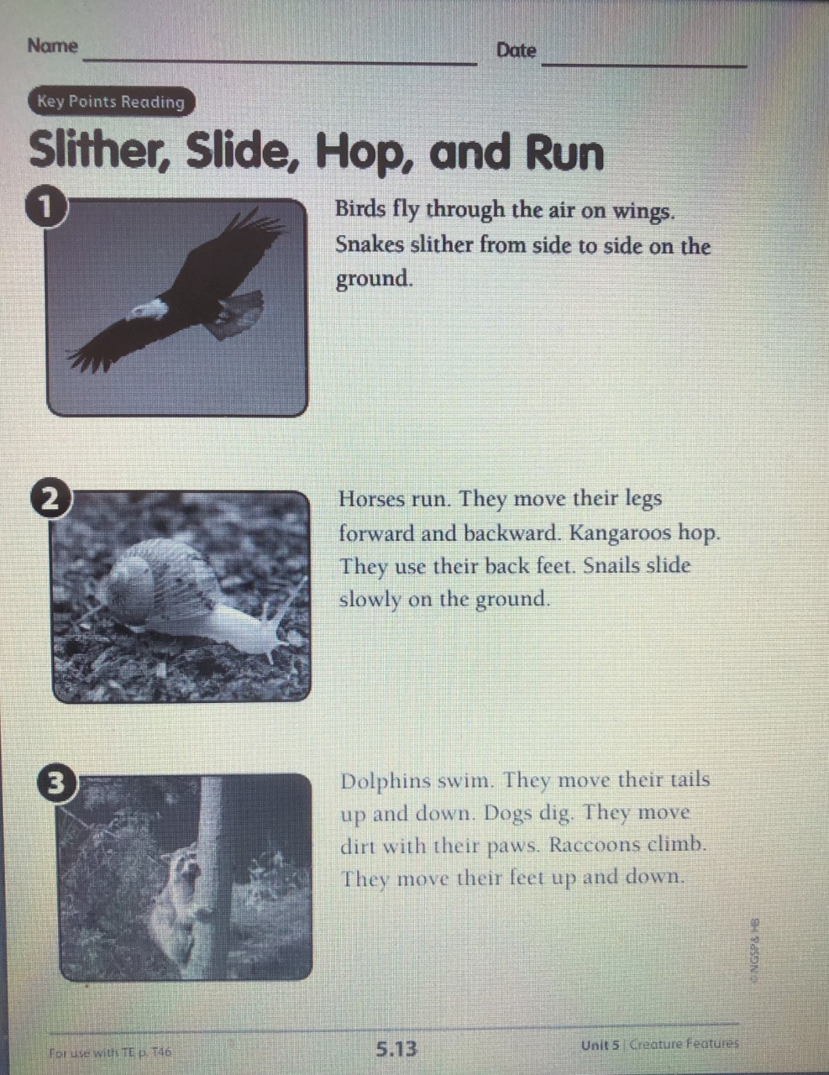

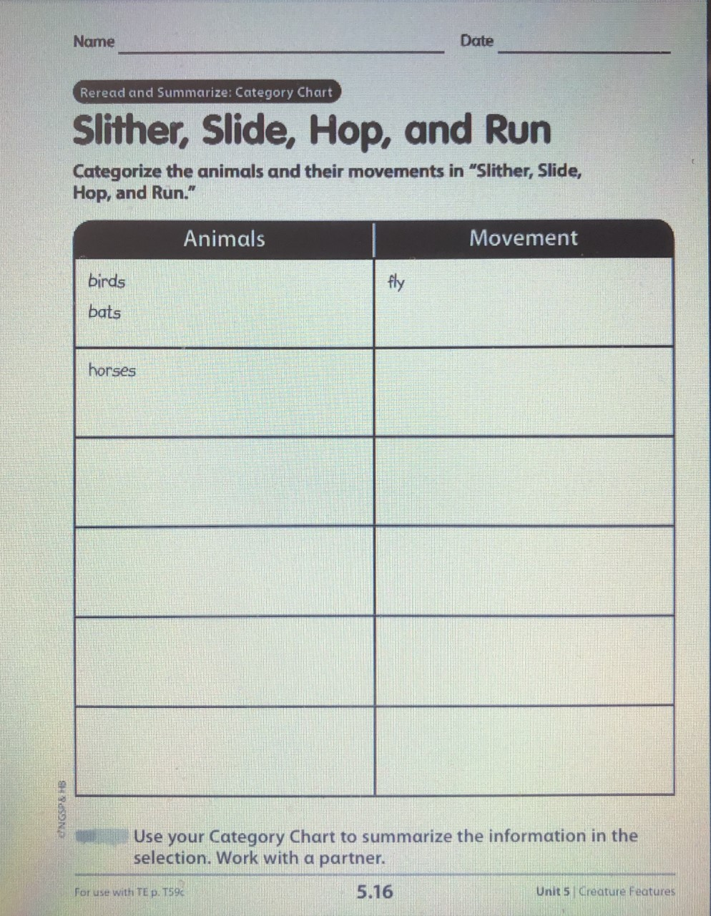

Garfield Public Schools
Remote Learning
Lesson Plans
Grade 1 – ESL

Tuesday, May 19, 2020 - DAY # 41 (Part 2)
OBJECTIVE: SWBAT:
- read and understand a nonfiction story about animal movement.
- watch and understand a video on animal movement.
- categorize animal movement using a category chart.
- produce sentences describing animal movement.

STANDARD(S):
WIDA 2 – The Language of Language Arts
WIDA 4 - The Language of Science
SL.1.2 RI.1.1
W.1.2
TIME FRAME:
20 min. (Day 2 of assignment)
Activity Directions:
- Watch the YouTube video - Animals in Action/ Movement Song for Kids.

https://www.youtube.com/watch?v=CT86Dl442jA

- Write a sentence about how each of the following animals move.
monkey / eagle / squirrel / fish
Remember to begin your sentence with a capital letter and end it with a period.

Differentiation Strategies for Remote Learning
Access to Google Translate; bilingual dictionaries; teacher’s email for clarification
Beginning Level: communicate through drawings
Intermediate Level: form simple sentences using word banks
Advanced Level: produce original sentences

Assessment:
WIDA WRITING RUBRIC
WIDA SPEAKING RUBRIC

Garfield Public Schools
Remote Learning
Lesson Plans
Grade 1 – ESL

Wednesday, May 20, 2020 - DAY # 42 (Part 1)
OBJECTIVE: SWBAT:
- read and understand a nonfiction story about how weather changes.
- answer questions about key details in the text.
- produce sentences using key vocabulary from the story.

STANDARD(S):
WIDA 2 – The Language of Language Arts
WIDA 4 - The Language of Science
SL.1.2 RI.1.2
L.1.1
TIME FRAME:
20 min. (Assignment to be carried out over two (2) days)
Activity Directions:
- Go to Epic.com
https://www.getepic.com/app/read/9034

- Listen to the read aloud of “How Does Weather Change?
- Go to page 23 of the story (The Glossary) and use the following words in a sentence of your own:
- clouds
- rain
- snow
- weather
Differentiation Strategies for Remote Learning
Access to Google Translate; bilingual dictionaries; teacher’s email for clarification
Beginning Level: communicate through drawings
Intermediate Level: form simple sentences using word banks
Advanced Level: produce original sentences

Assessment:
WIDA WRITING RUBRIC
WIDA SPEAKING RUBRIC

Garfield Public Schools
Remote Learning
Lesson Plans
Grade 1 – ESL

Thursday, May 21, 2020 - DAY # 43 (Part 2)
OBJECTIVE: SWBAT:
- read and understand a nonfiction story about how weather changes.
- answer questions about key details in the text.
- produce sentences using key vocabulary from the story.
STANDARD(S):
WIDA 2 – The Language of Language Arts
WIDA 4 - The Language of Science
SL.1.2 RI.1.2
L.1.1
TIME FRAME:
20 min. (Day 2 of assignment)
Activity Directions:

- Listen again to the read aloud of “How Does Weather Change?” on Epic.com.
https://www.getepic.com/app/read/9034
- Take the quiz at the end of the story. Remember to write your answers in your notebook or on paper.
Differentiation Strategies for Remote Learning
Access to Google Translate; bilingual dictionaries; teacher’s email for clarification
Beginning Level: communicate through drawings
Intermediate Level: form simple sentences using word banks
Advanced Level: produce original sentences

Assessment:
WIDA WRITING RUBRIC
WIDA SPEAKING RUBRIC

Garfield Public Schools
Remote Learning
Lesson Plans
Grade 1 – ESL

Friday, May 22, 2020 - DAY # 44 (Part 3)
OBJECTIVE: SWBAT:
- read and understand a nonfiction story about how the weather changes.
- answer questions about key details in the text.
- produce sentences using key vocabulary from the story.
STANDARD(S):
WIDA 2 – The Language of Language Arts
WIDA 4 - The Language of Science
SL.1.2 RI.1.2
L.1.1
TIME FRAME:
20 min. (Day 3 of assignment)
Activity Directions:
- Look at page 71 (REACH) – Share What You Know
- Name your favorite kind of weather.
- Tell why you like that weather.
- Draw something that you do in that weather.

Differentiation Strategies for Remote Learning
Access to Google Translate; bilingual dictionaries; teacher’s email for clarification
Beginning Level: communicate through drawings
Intermediate Level: form simple sentences using word banks
Advanced Level: produce original sentences

Assessment:
WIDA WRITING RUBRIC
WIDA SPEAKING RUBRIC

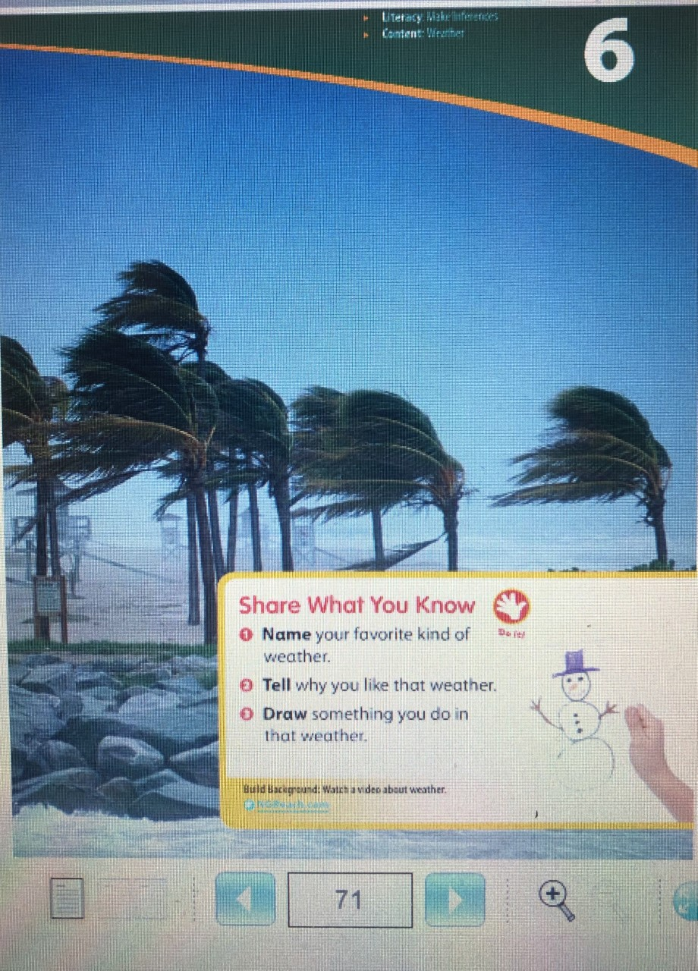
Lesson Plans
Grade 1 – ESL

Tuesday, May 26 - DAY # 45
OBJECTIVE: SWBAT: Read and understand key details in the fiction story, “It’s Raining Cats and Frogs”.
SWBAT: Identify the effects of rain.
SWBAT: Use a cause and effect chart
SWBAT: Read and understand key vocabulary words from a story.

STANDARD(S):
W.1.2
SL.1.2
RL.1.1
RF.1.3
WIDA 2: The Language of Language Arts
WIDA 4: The Language of Science
TIME FRAME: 20 minutes

Activity Directions:
1. Go togetepic.com and read the story, “It’s Raining Cats and Frogs.”
2. Listen to a read aloud of “It’s Raining Cats and Frogs.”
3. Think about what happens when rain falls all day.
4. Use the cause and effect chart on page 6.2 to write a short sentence in each effect box
telling whathappens when rain falls all day.
5. Look at the words in the box and the end of the story. Read them slow, and read them fast!

Differentiation Strategies for Remote Learning
Access to Google Translate; bilingual dictionaries; teacher’s email for clarification
Beginning Level: communicate through drawings
Intermediate Level: form simple sentences using word banks
Advanced Level: produce original sentences

Assessment:
WIDA WRITING RUBRIC
WIDA SPEAKING RUBRIC

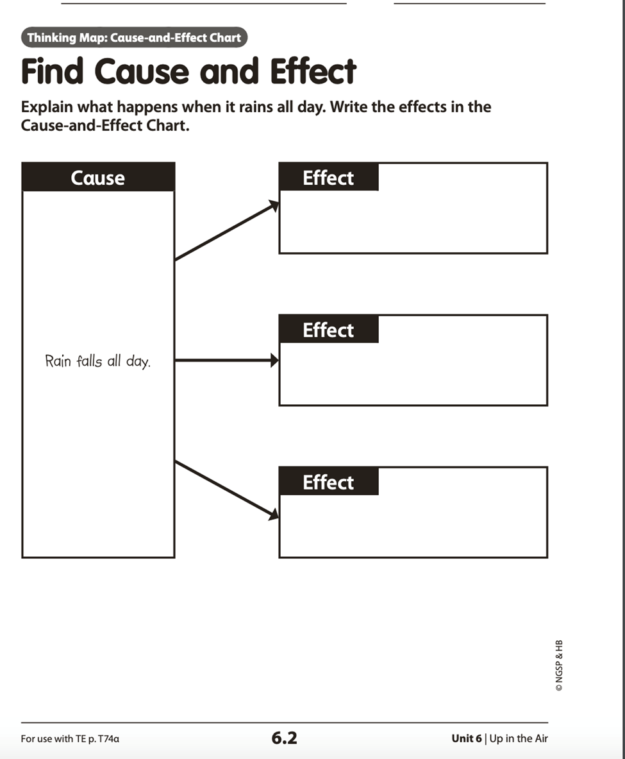

Garfield Public Schools
Remote Learning
Lesson Plans
Grade 1 – ESL

Wednesday, May 27 - DAY # 46
OBJECTIVE:
SWBAT: listen to and understand a science nonfiction read aloud.
SWBAT: write responses to comprehension questions about the science nonfiction text.
SWBAT: produce complete sentences using key vocabulary words from the science nonfiction text.
SWBAT: use a cause and effect chart to write the effects of wind.

STANDARD(S):
W.1.2
RL.1.2
SL.1.2
WIDA 2- The Language of Language Arts
WIDA 4- The Language of Science
TIME FRAME: 20 minutes - 3 Day Assignment (Day 1)

Activity Directions:
- Go to YouTube.com and listen to the video of, “Monday’s Read Aloud, I Face the Wind.”
https://www.youtube.com/watch?v=oszWsXQubjA
- Look at page 94 -“Talk About It.”
- Answer the question 1-3 using the sentence starters.

Differentiation Strategies for Remote Learning
Access to Google Translate; bilingual dictionaries; teacher’s email for clarification
Beginning Level: communicate through drawings
Intermediate Level: form simple sentences using word banks
Advanced Level: produce original sentences

Assessment:
WIDA WRITING RUBRIC
WIDA SPEAKING RUBRIC

Garfield Public Schools
Remote Learning
Lesson Plans
Grade 1 – ESL

Thursday, May 28- DAY # 47
OBJECTIVE:
SWBAT: listen to and understand a science nonfiction read aloud.
SWBAT: write responses to comprehension questions about the science nonfiction text.
SWBAT: produce complete sentences using key vocabulary words from the science nonfiction text.
SWBAT: use a cause and effect chart to write the effects of wind.

STANDARD(S):
W.1.2
RL.1.2
SL.1.2
WIDA 2- The Language of Language Arts
WIDA 4- The Language of Science

TIME FRAME: 20 minutes - 3 Day Assignment- (Day 2)

Activity Directions:
- Listen to the story again, “Monday’s Read Aloud, I Face the Wind.”

https://www.youtube.com/watch?v=oszWsXQubjA

- Write a sentence for each of the following vocabulary words:
1. strong 2. blow 3. kite 4. feel 5.umbrella

Differentiation Strategies for Remote Learning
Access to Google Translate; bilingual dictionaries; teacher’s email for clarification
Beginning Level: communicate through drawings
Intermediate Level: form simple sentences using word banks
Advanced Level: produce original sentences

Assessment:
WIDA WRITING RUBRIC
WIDA SPEAKING RUBRIC

Garfield Public Schools
Remote Learning
Lesson Plans
Grade 1 – ESL

Friday, May 29- DAY # 48
OBJECTIVE:
SWBAT: listen to and understand a science nonfiction read aloud.
SWBAT: write responses to comprehension questions about the science nonfiction text.
SWBAT: produce complete sentences using key vocabulary words from the science nonfiction text.
SWBAT: use a cause and effect chart to write the effects of wind.

STANDARD(S):
W.1.2
RL.1.2
SL.1.2
WIDA 2- The Language of Language Arts
WIDA 4- The Language of Science

TIME FRAME: 20 minutes - 3 Day Assignment- (Day 3)

Activity Directions:
- Look at page 6.7-Cause and Effect Chart. (I Face the Wind)
- Write the effects of the wind from the story in the chart.
- Draw a picture of yourself outside on a windy day.

Differentiation Strategies for Remote Learning
Access to Google Translate; bilingual dictionaries; teacher’s email for clarification
Beginning Level: communicate through drawings
Intermediate Level: form simple sentences using word banks
Advanced Level: produce original sentences

Assessment:
WIDA WRITING RUBRIC
WIDA SPEAKING RUBRIC

