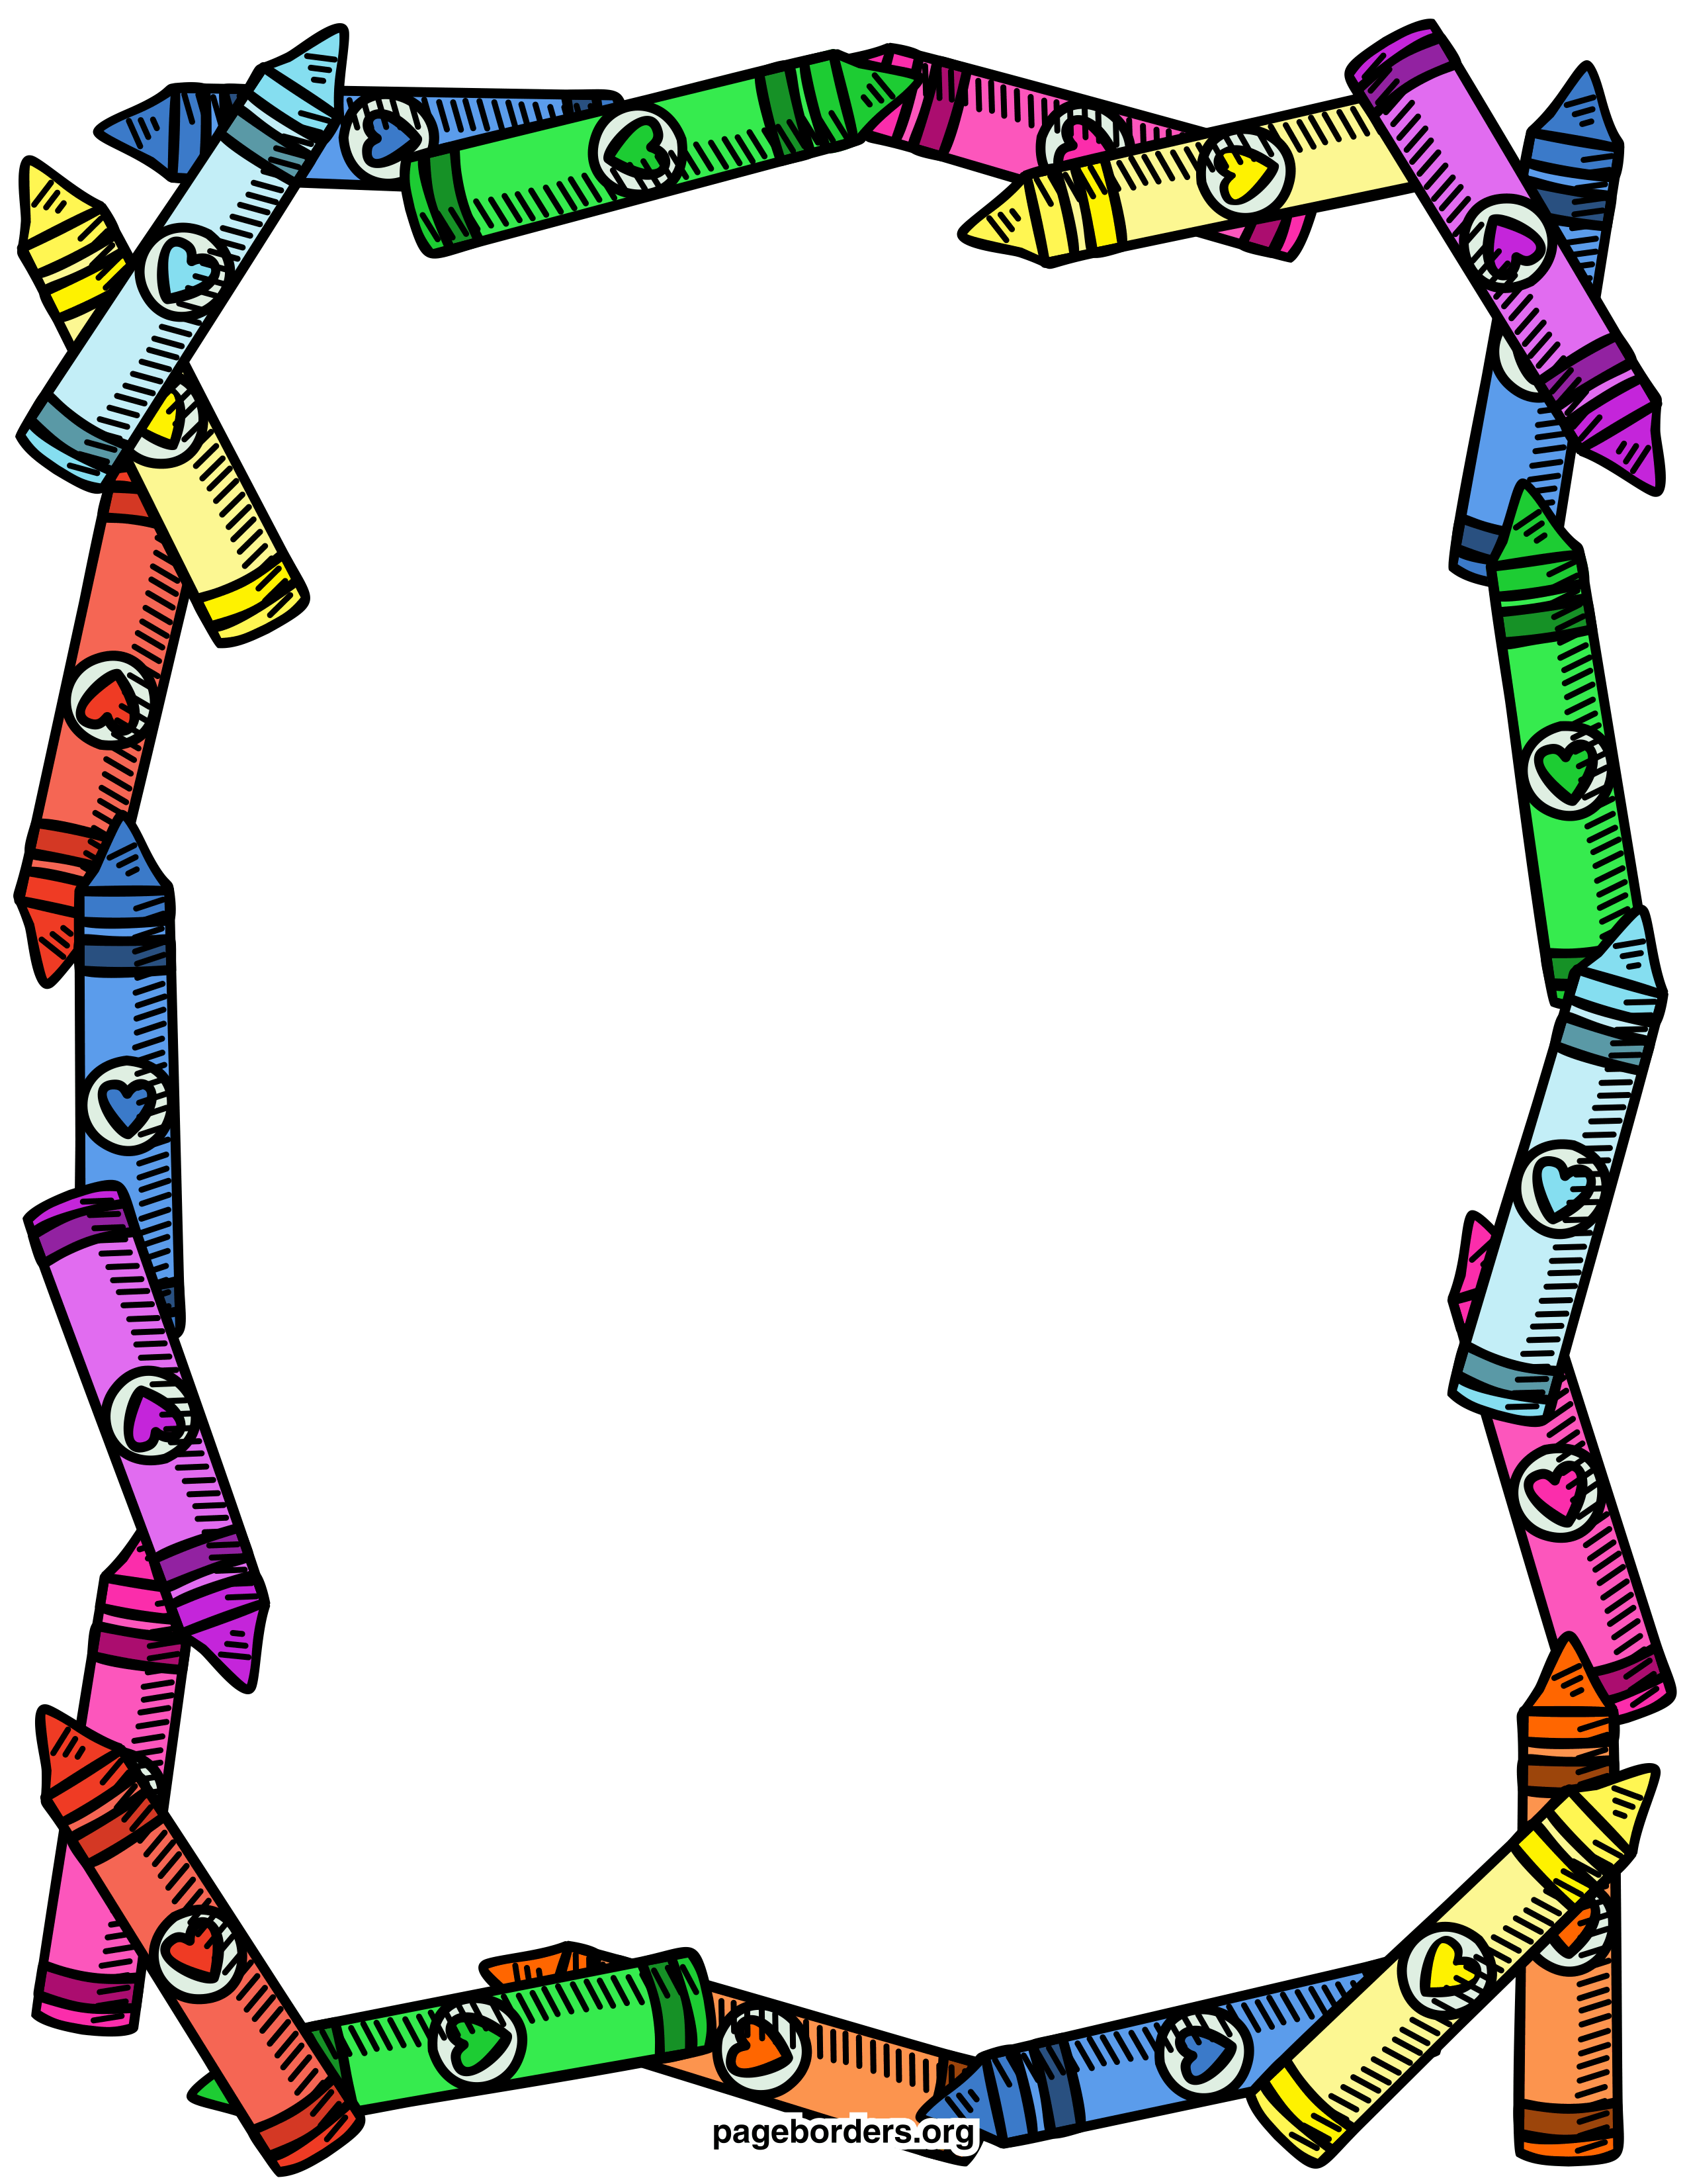
Third Grade Supply List
2021-2022

4 composition notebooks, Marble Cover, wide ruled (no spiral
notebooks)
5 folders, poly, 2 pocket, red, orange, yellow, green, blue
1 Bx 24 Crayola Crayons
1 Pk Expo Dry Erase markers, Fine, Low Odor, Asst. 4/Pk
4 Pk highlighters
5 Elmer’s Glue Sticks
1 pair student Scissors
2 Dz. Dixon Pencils #2, Ticonderoga (no mechanical pencils)
1 Pk of 24 Crayola Colored Pencils
1 Pk pencil top erasers
Large zippered pencil case (soft)
1 Pk Index Cards, 3” x 5”, Ruled, 100/Pk, white

