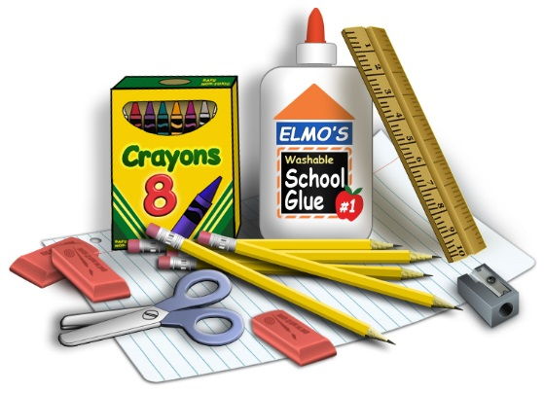
Second Grade Supply List
The following items are due the very first week of school:
6 boxes of No. 2 pencils (to be used throughout the year)
2 pencil sharpeners with covers to catch shavings
3 writing notebooks
2 or more sticky note pads
3-4 sturdy pocket folders
2 packs of index cards
2 boxes of 24 Crayola crayons (no more than 24 please)
6 or more erase board markers (Expo-fine tip only)
1 box of 8 markers
1 pair of scissors
5 or more large glue sticks
1 bottle of Elmer’s glue
1 large zippered pencil case (NO plastic boxes without zipper)
1 backpack

