Garfield Public Schools
Remote Learning Lesson Plans
Grade K- ESL

Day 30 - May 4, 2020
OBJECTIVE: Students will be able to draw a picture of their family doing something together. Students will be able to discuss their picture with a family member and name the things they are doing.

STANDARD(S):
compose informative/explanatory texts in which they name what they are writing about and supply some information about the topic.
RL.K.2: With prompting and support, identify the main topic and retell key details of a text.
WIDA: 2 – The Language of Language Arts

TIME FRAME: 15 minutes

Activity Directions:
Activity is from the Reach book. What Makes a Family? With crayons and paper and markers, students will draw a picture of something they like to do with their family. Discuss the picture with your family. Use the sentence frame to write about your picture:
I like to ________ with my family.

Video: Reach Unit 1: Read along.

Learning Materials: Google translate

Assessment: WIDA Writing Rubric

Day 31 - May 5, 2020
OBJECTIVE: Students will be able to ask and answer questions about what the family is doing in the picture. Students will be able to draw or write 1 sentence about the family in the picture. The family is __________.

STANDARD(S):
W.K.2: Use a combination of drawing, dictating, and writing to compose informative/explanatory texts in which they name what they are writing about and supply some information about the topic.
*R.L.K.2: With prompting and support, identify the main topic and details of a text.
WIDA 2 – The Language of Language Arts.

TIME FRAME: 20 Minutes.

Activity Directions:
*Students will look at the picture on page 5 of the Reach book. Students will discuss the picture with a family member. What are the people doing in the picture? Students will draw/illustrate or write 1 sentence about the picture. Example:

The girl is ______________.

Videos:
Reach Book Page 5 from Unit 1

Learning Materials: Google translate if needed.
Assessment: WIDA Writing Rubric

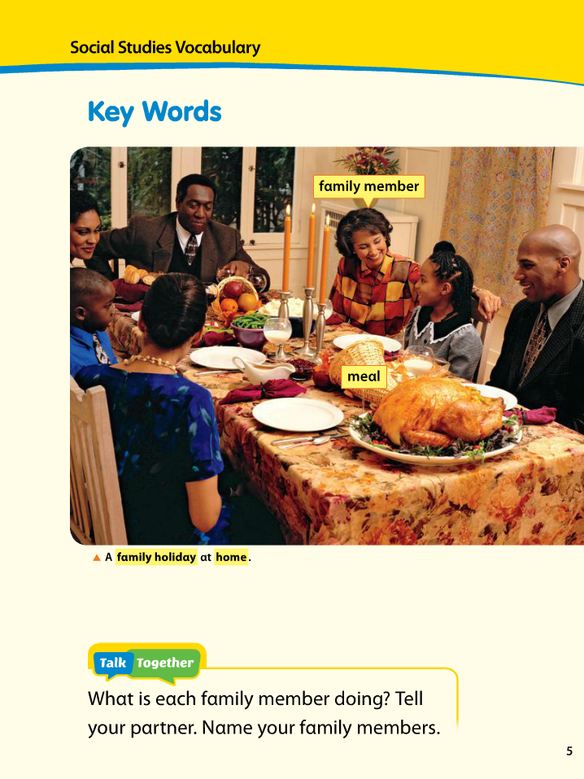
Day 32 - May 6, 2020
OBJECTIVE: SWBAT: Read and identify pictures in the story Families in Many Cultures. SWBAT: Ask and answer questions.
STANDARD(S):

*R.L.K.2: With prompting and support, identify the main topic and details of a text.
WIDA: 2 – The Language of Language Arts
TIME FRAME: 20 minutes

__________________________________________________________________________________
Activity Directions:
*Click on the attached link. Reach Unit 1. Students will look at the pictures in the story. Discuss with a family member what the families are doing in each picture.

https://drive.google.com/file/d/1fFSdL4Au4eXdXjG9bDOBmC58ymP_ftYg/view

Write a sentence about something the families in the story do together. Use the sentence frame to help you:

The family __________________ together.

Video: Reach Unit 1 : Families in Many Cultures.

Learning Materials: Google translate if needed.

Assessment: WIDA Writing Rubric

p.2

Garfield Public Schools
Remote Learning Lesson Plans
Grade K ESL

Day 33 - May 7, 2020
OBJECTIVE:
Students will be able to draw/illustrate or write about what was their favorite part in the story.

STANDARD(S):
W.K.2: Use a combination of drawing, dictating, and writing to compose informative/explanatory texts in which they name what they are writing about and supply some information about the topic.
WIDA: 2 – The Language of Language Arts
TIME FRAME: 15 minutes

Activity Directions:
Click on the attached YouTube link: https://www.youtube.com/watch?v=O-sls-CzzlQ

Read the story: Me and My Family Tree by Joan Sweeney
Draw/illustrate and write 1 sentence about your favorite part of this story.
Example: My favorite part was ____________________.

Learning Materials: Google translate if needed.
Assessment: WIDA Writing Rubric

Remote Learning Lesson Plans

Grade K
Day 34 - May 8, 2020
OBJECTIVE:
Students will identify 3 favorite places to go with their families. Students will draw/illustrate write what are their favorite places using a T-chart. (Reach page 34.)

STANDARD(S):
W.K.2: Use a combination of drawing, dictating, and writing to compose informative/explanatory texts in which they name what they are writing about and supply some information about the topic.
WIDA: 2 – The Language of Language Arts
TIME FRAME: 15 minutes
Activity Directions:
Students will draw a picture and name the place they like to go with their families.
For example: park/ picture of park
Store/picture of a store
Students can write 2 or 3 sentences: I like to go to the _________________.

Learning Materials: Google translate if needed.
Assessment: WIDA Writing Rubric
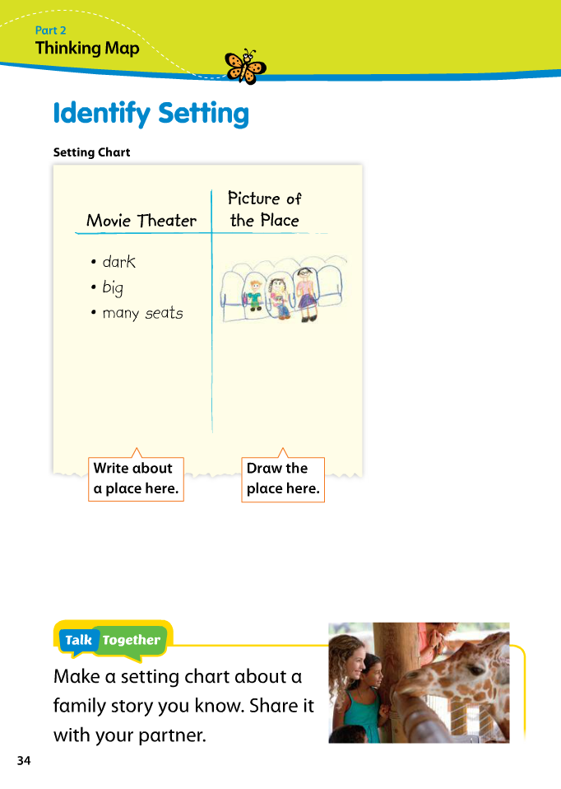
Days 35 & 36 - May 11, 2020 and May 12, 2020
OBJECTIVE:
Students will be able to read a story from the Reach Book link attached and retell what the boy did in the story with his dad. Students will also be able to draw a picture of something they do with their family that is special to them.
STANDARD(S):
W.K.2: Use a combination of drawing, dictating, and writing to compose informative/explanatory texts in which they name what they are writing about and supply some information about the topic.
*R.L.K.2: With prompting and support, identify the main topic and details of a text.
WIDA: 2 – Language of Language Arts, 5 – The Language of Social Studies

TIME FRAME: 15 minutes
Activity Directions:
Students click on the link and listen to the story, Papa and Me from the Reach book.
Click on link below: https://www.youtube.com/watch?v=jMjTUxwxu50

Students will then retell the story of the boy and his Papa and then draw/illustrate and write two sentences about what they do with a family member that is special to them. For example: I like to ________________with my Mom. (Dad, Brother, Sister, Aunt) etc.
Please do everything in your notebook.

Beginners: draw/illustrate pictures
Intermediate: Complete 2 sentences.
Learning Materials: Google translate if needed.
Assessment: WIDA Writing Rubric

Day 37 -May 13, 2020
OBJECTIVE:
Students will be able to draw a picture or write what they do at home to help.
STANDARD(S):
W.K.2: Use a combination of drawing, dictating, and writing to compose informative/explanatory texts in which they name what they are writing about and supply some information about the topic.
WIDA: 2 – Language of Language Arts, 5 – The Language of Social Studies

TIME FRAME: 15 minutes
Activity Directions:
Students will trace their hand on a piece of paper in their notebook. They will then draw/ or write in each finger what they do to help out at home. For example: 1 finger can have a picture or say: I wash the dishes. Next finger: I clean up my toys etc. Page 65 of Reach Book: Helping Hands.

Draw pictures to match your sentences.
Please do everything in your notebook.

Beginners: draw/illustrate pictures
Intermediate: Draw/label and write a sentence.
Learning Materials: Google translate if needed.
Assessment: WIDA Writing Rubric

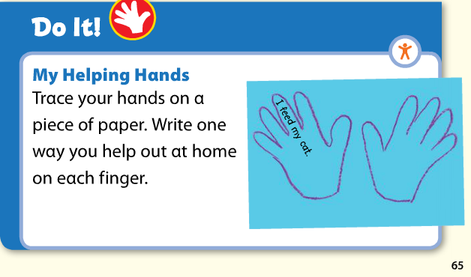

Days 38 & 39 - May 14th and May 15th
OBJECTIVE: Students will watch a YouTube video about things that are alive. Students will be able to identify 3 different things that are alive in their house. They will illustrate/draw a picture of these things and then label it.

STANDARD(S):
W.K.2: Uses a combination of drawing, dictating and writing to compose informative/explanatory texts in which they name what they are writing about and supply some information about the topic.
RL.K.2: With prompting and support, identify the main topic and retell key details of the video.
WIDA: 2 – The Language of Language Arts, 4 – The Language of Science.

TIME FRAME: 20 minutes

Activity Directions:
Review the video and draw/illustrate 3 things that are alive in your house.
Please do all your drawings and writings in your ESL notebook.
YouTube Video: Living and Nonliving things. (Kindergarten): https://www.youtube.com/watch?v=NG-FaXNiIfU
Writing Examples:
My fish is alive.
My plant is alive.

Beginners: draw/illustrate pictures
Intermediate: Draw/label and write a sentence.

Learning Materials: Google translate

Assessment: WIDA Writing Rubric

