Grade2/3–ESL
DAY # 20-4/20/20
OBJECTIVE:
• Students will be able to ask and answer questions about key details in a text.
• Students will be able to read text with purpose and understanding, and write information

STANDARD(S):
RI.2.1, RI.2.2, W2.2
R1.3.1,R1.3.2, W3.2
WIDA 2 (Language of Language Arts)
WIDA 5 (Language of Social Studies)
TIME FRAME:
20 minutes

Activity Directions:

Use Information:

1. Think about the signs and symbols you have read about.
2. Draw a symbol for a school, a library, a house, a sunny day, a rainy day.
3. Next to each symbol, write what it means.

Differentiation:
Beginning level students will write words they know, draw a picture, or write in their home language.
Intermediate students will use a language frame or sentence starter.
Advanced students will complete the activity on their own and relate to personal experience.
Assessment: WIDA writing Rubric

Grade2/3–ESL
DAY # 21-4/21/20
OBJECTIVE:
• Students will be able to ask and answer questions about key details in a text.
• Students will be able to read text with purpose and understanding, and write information
STANDARD(S):
RI.2.1, RI.2.2, W2.2
R1.3.1,R1.3.2, W3.2
WIDA 2 (Language of Language Arts)
WIDA 5 (Language of Social Studies)
TIME FRAME:
20 minutes
Activity Directions:

Suffixes
1. Read about suffixes and word endings on pg 226.
2. Read these sentences:
The first map is useful because I can read it.
The second map is useless because it is torn.
3. Copy and fill in the chart at the bottom of page 226. Use the suffix to make a new word.
4.Pick 4 words and write a sentence for each of the 4 new words.
Differentiation:
Beginning level students will write words they know, draw a picture, or write in their home language.
Intermediate students will use a language frame or sentence starter.
Advanced students will complete the activity on their own and relate to personal experience.
Assessment: WIDA writing Rubric

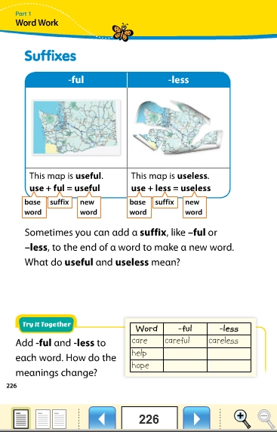

Grade2/3–ESL
DAY # 22-4/22/20 (2 day lesson, Day 22 and Day 23)
OBJECTIVE:
• Students will be able to ask and answer questions about key details in a text.
• Students will be able to read text with purpose and understanding, and write information
STANDARD(S):
RI.2.1, RI.2.2, W2.2
R1.3.1,R1.3.2, W3.2
WIDA 2 (Language of Language Arts)
WIDA 5 (Language of Social Studies)
TIME FRAME:
20 minutes
Activity Directions:

Compare Genres: Informational Story and Poem
- Read the poem on page 227,228, 229. Poems put pictures in your mind. This Haiku poem tells you how to get to an interesting place.
- Answer the questions in your notebook.
- What does this poem tell you? It tells me____________.
- What happens after you turn right?__________________.
- Think about the informational story we read last week, If Maps Could Talk.
3. How are the map story and the poem the same?
They are the same because___________________.
4.How are the map story and the poem different?
They are different because____________________.

Differentiation:
Beginning level students will write words they know, draw a picture, or write in their home language.
Intermediate students will use a language frame or sentence starter.
Advanced students will complete the activity on their own and relate to personal experience.
Assessment: WIDA writing Rubric

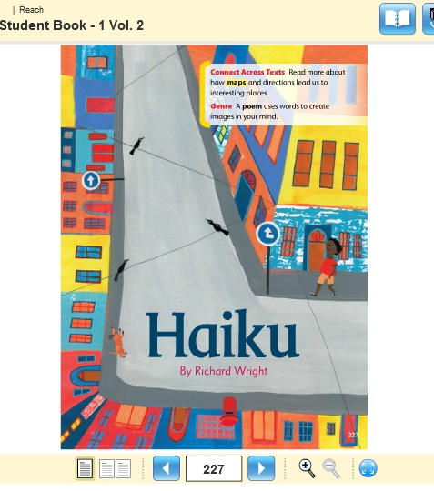

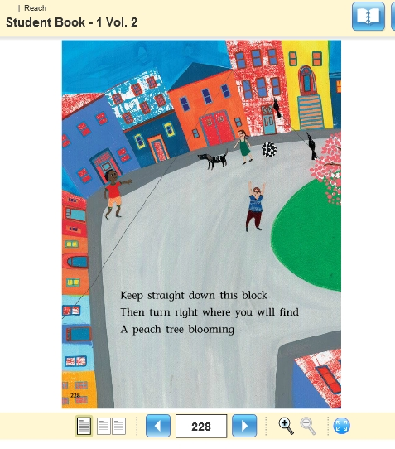

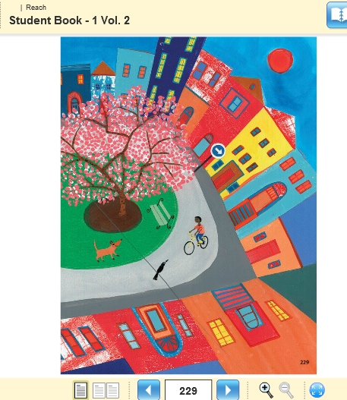

Grade2/3–ESL
DAY # 23-4/23/20 ( This lesson continues for the 2nd day)
OBJECTIVE:
• Students will be able to ask and answer questions about key details in a text.
• Students will be able to read text with purpose and understanding, and write information
STANDARD(S):
RI.2.1, RI.2.2, W2.2
R1.3.1,R1.3.2, W3.2
WIDA 2 (Language of Language Arts)
WIDA 5 (Language of Social Studies)
TIME FRAME:
20 minutes
Activity Directions:

Compare Genres: Informational Story and Poem
- Read the poem on page 227,228, 229. Poems put pictures in your mind. This Haiku poem tells you how to get to an interesting place.
- Answer the questions in your notebook.
- What does this poem tell you? It tells me____________.
- What happens after you turn right?__________________.
- Think about the informational story we read last week, If Maps Could Talk.
3. How are the map story and the poem the same?
They are the same because___________________.
4.How are the map story and the poem different?
They are different because____________________.

Differentiation:
Beginning level students will write words they know, draw a picture, or write in their home language.
Intermediate students will use a language frame or sentence starter.
Advanced students will complete the activity on their own and relate to personal experience.
Assessment: WIDA writing Rubric

Grade2/3–ESL
DAY # 24-4/24/20-Friday
OBJECTIVE:

STANDARD(S):

TIME FRAME:

Activity Directions:

Grade2/3–ESL
DAY # 25-4/27/20
OBJECTIVE:
• Students will be able to ask and answer questions about key details in a text.
• Students will be able to read text with purpose and understanding, and write information

STANDARD(S):
RI.2.1, RI.2.2, W2.2
R1.3.1,R1.3.2, W3.2
WIDA 2 (Language of Language Arts)
WIDA 5 (Language of Social Studies)
TIME FRAME:
20 minutes
Activity Directions:

Adverbs:

1. Read page 231, Adverbs. Adverbs tell more about verbs. Many adverbs end with –ly.
2.Look at workbook page 8.3 . Copy the sentences. Underline the verb. Circle the adverb.
3. Write a sentence to tell how you got ready for school today. Use an adverb.

Differentiation:
Beginning level students will write words they know, draw a picture, or write in their home language.
Intermediate students will use a language frame or sentence starter.
Advanced students will complete the activity on their own and relate to personal experience.
Assessment: WIDA writing Rubric

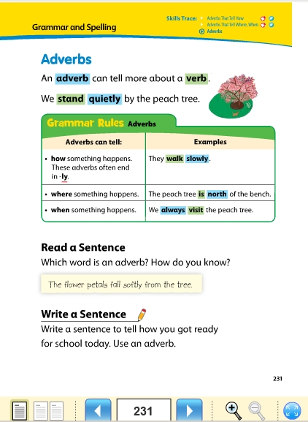

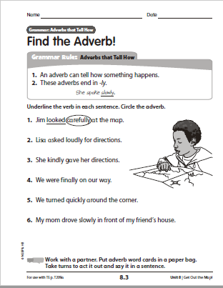

Grade2/3–ESL
DAY # 26-4/28/20 (This lesson covers 2 days.)
OBJECTIVE:
• Students will be able to ask and answer questions about key details in a text.
• Students will be able to read text with purpose and understanding, and write information

STANDARD(S):
RI.2.1, RI.2.2, W2.2
R1.3.1,R1.3.2, W3.2
WIDA 2 (Language of Language Arts)
WIDA 5 (Language of Social Studies)

TIME FRAME:
20 minutes
Activity Directions:

Jack and the Hike
1.Read the chant on pg 232.
2. Look at the map on page 233. Write 3 sentences to tell a story about how Jack gets to the lake. Remember to use capital letters, periods, and sequence words(first, next , last).
3. Start your story with this sentence: Jack is going to the lake.

Differentiation:
Beginning level students will write words they know, draw a picture, or write in their home language.
Intermediate students will use a language frame or sentence starter.
Advanced students will complete the activity on their own and relate to personal experience.
Assessment: WIDA writing Rubric

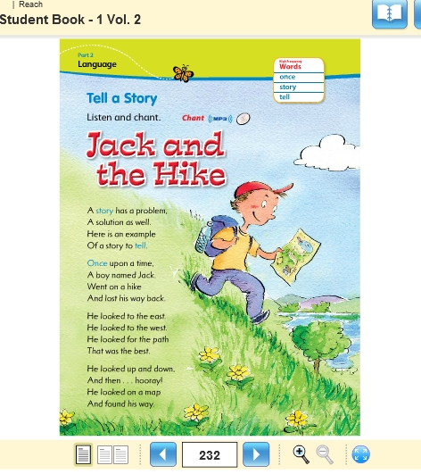

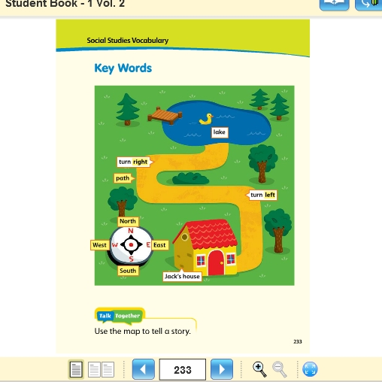

Grade2/3–ESL
DAY # 27-4/29/20 (This is the second day for this lesson)
OBJECTIVE:
• Students will be able to ask and answer questions about key details in a text.
• Students will be able to read text with purpose and understanding, and write information

STANDARD(S):
RI.2.1, RI.2.2, W2.2
R1.3.1,R1.3.2, W3.2
WIDA 2 (Language of Language Arts)
WIDA 5 (Language of Social Studies)

TIME FRAME:
20 minutes
Activity Directions:

Jack and the Hike
1.Read the chant on pg 232.
2. Look at the map on page 233. Write 3 sentences to tell a story about how Jack gets to the lake. Remember to use capital letters, periods, and sequence words(first, next , last).
3. Start your story with this sentence: Jack is going to the lake.

Differentiation:
Beginning level students will write words they know, draw a picture, or write in their home language.
Intermediate students will use a language frame or sentence starter.
Advanced students will complete the activity on their own and relate to personal experience.
Assessment: WIDA writing Rubric

Grade2/3–ESL
DAY # 28-4/30/20
OBJECTIVE:
• Students will be able to ask and answer questions about key details in a text.
• Students will be able to read text with purpose and understanding, and write information

STANDARD(S):
RI.2.1, RI.2.2, W2.2
R1.3.1,R1.3.2, W3.2
WIDA 2 (Language of Language Arts)
WIDA 5 (Language of Social Studies)

TIME FRAME:
20 minutes
Activity Directions:

Academic Key Words
1. Read the information on page 235.
2. Write the words in yellow 3 times.
3. Pick 3 yellow words and write a sentence for each.
Differentiation:
Beginning level students will write words they know, draw a picture, or write in their home language.
Intermediate students will use a language frame or sentence starter.
Advanced students will complete the activity on their own and relate to personal experience.
Assessment: WIDA writing Rubric

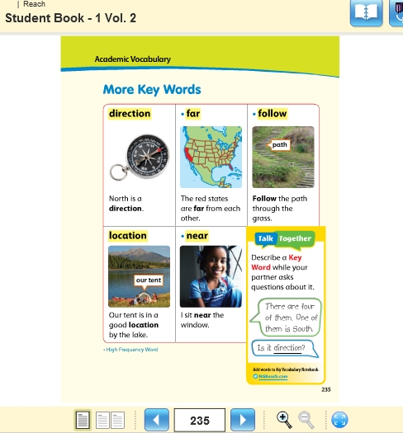

Grade2/3–ESL
DAY # 29-5/1/20 Friday
OBJECTIVE:

STANDARD(S):

TIME FRAME:

Activity Directions:

