Day 30 - May 4, 2020
OBJECTIVE: What happens when nature loses its balances?
SWBAT:
*Use word structure to determine word meaning.
*read fiction and or nonfiction and complete a reading response prompt.
*practice writing in complete sentences, revising and editing.
STANDARD(S):
W.4.10. Write routinely over extended time frames (time for research, reflection, metacognition/self-correction and revision) and shorter time frames (a single sitting or a day or two for a range of discipline-specific tasks, purposes, and audiences.
RL.4.10. By the end of the year, read and comprehend literature, including stories, dramas, and poems at grade level text-complexity or above, with scaffolding as needed.
RF.4.4: Read with sufficient accuracy and fluency to support comprehension.
L.4.1: Demonstrate command of the conventions of standard English grammar and usage when writing or speaking.
RL: 5.1, 5.2
RF: 5.3, 5.4
W.5.9
WIDA 1,2, 4: Social & Instructional Language, The Language of Language Arts, The Language of Science
TIME FRAME: 20 minutes
Activity Directions:

Students will identify the following vocabulary words:

- Amount 2. increase 3. behavior 4. supply 5. decrease
Students will use google translate to:
~ Listen & repeat word 3 times
~ Write definition and a sentence for each vocabulary word either in your notebook or send a Word document to your ESL teacher in TEAMS.
Learning Materials: Google translate, Reach Level D ~ Teacher’s Edition
Assessment: WIDA Writing Rubric

Days 31& 32 - May 5-6, 2020
(2 day assignment)
OBJECTIVE:
* use word structure to determine word meaning.
*read fiction and or nonfiction and complete a reading response prompt.
*practice writing in complete sentences, revising and editing.
STANDARD(S):

W.4.10. Write routinely over extended time frames (time for research, reflection, metacognition/self-correction and revision) and shorter time frames (a single sitting or a day or two for a range of discipline-specific tasks, purposes, and audiences.
RL.4.10. By the end of the year, read and comprehend literature, including stories, dramas, and poems at grade level text-complexity or above, with scaffolding as needed.
RF.4.4: Read with sufficient accuracy and fluency to support comprehension.
L.4.1: Demonstrate command of the conventions of standard English grammar and usage when writing or speaking.
RL: 5.1, 5.2
RF: 5.3, 5.4
W.5.9

WIDA 1,2, 4: Social & Instructional Language, The Language of Language Arts, The Language of Science
TIME FRAME: 20 Minutes.

Activity Directions: Students will read story “When the Pigs took Over” by Arthur Dorros.
https://drive.google.com/file/d/1UE8uFcbicqu1j0_AIeZb9_lPB53mwuGB/view (Part 1)
https://drive.google.com/file/d/1gRHuWvQSO1c2uK7lPKQI27gavebsFLOM/view (Part 2)

Students will practice reading skills.Students use Reach textbook page 94 # 1-3. Talk About It.
Students build comprehension skills. Students answer questions #1-3. Students write complete sentences using proper capitalization, spelling & punctuation.
Write your answer in your notebook or send a Word document to your ESL teacher in TEAMS.

Learning Materials: Reach Level D, Google translate as needed.
Assessment: WIDA Writing Rubric

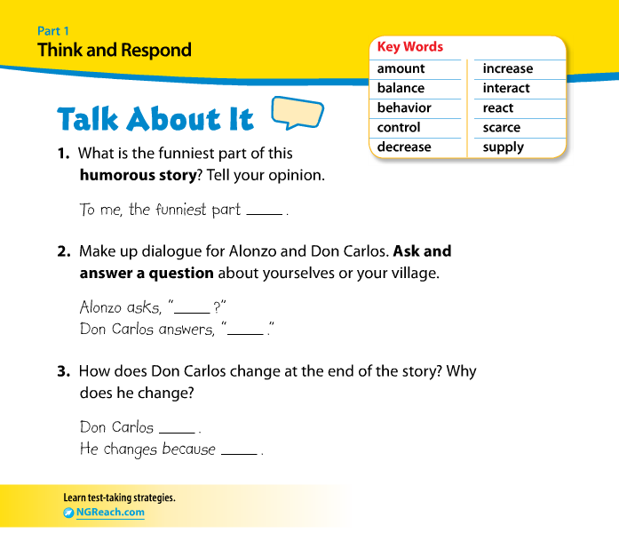

Day 33 - May 7,2020
OBJECTIVE: Students practice listening skills. Students will be able to read the text with purpose and understanding, and write information.
SWBAT:
*Use word structure to determine word meaning.
STANDARD(S):
W.4.10. Write routinely over extended time frames (time for research, reflection, metacognition/self-correction and revision) and shorter time frames (a single sitting or a day or two for a range of discipline-specific tasks, purposes, and audiences.
RL.4.10. By the end of the year, read and comprehend literature, including stories, dramas, and poems at grade level text-complexity or above, with scaffolding as needed.
RF.4.4: Read with sufficient accuracy and fluency to support comprehension.
L.4.1: Demonstrate command of the conventions of standard English grammar and usage when writing or speaking.
RL: 5.1, 5.2
RF: 5.3, 5.4
W.5.9
WIDA 1,2, 4: Social & Instructional Language, The Language of Language Arts, The Language of Science
TIME FRAME: 20 minutes
Activity Directions:
Students watch video about our food chain “Natures Balance Video”.
https://drive.google.com/file/d/1TcLvNyqc0PvegGAqHWD2n3weoDYqUFHh/view

Students write a paragraph about video using vocabulary words: amount, increase, behavior, supply & decrease.

Learning Materials: Google translate, Reach book

Assessment: WIDA Writing Rubric

Day 34 - May 8, 2020
OBJECTIVE: Practice fluency skills
* use word structure to determine word meaning.
*read fiction and or nonfiction and complete a reading response prompt.
STANDARD(S):

W.4.10. Write routinely over extended time frames (time for research, reflection, metacognition/self-correction and revision) and shorter time frames (a single sitting or a day or two for a range of discipline-specific tasks, purposes, and audiences.
RL.4.10. By the end of the year, read and comprehend literature, including stories, dramas, and poems at grade level text-complexity or above, with scaffolding as needed.
RF.4.4: Read with sufficient accuracy and fluency to support comprehension.
L.4.1: Demonstrate command of the conventions of standard English grammar and usage when writing or speaking.
RL: 5.1, 5.2
RF: 5.3, 5.4
W.5.9

WIDA 1,2, 4: Social & Instructional Language, The Language of Language Arts, The Language of Science
TIME FRAME: 20 Minutes.

Activity Directions: Students will answer the following questions:
Imagine that your own community gets out of balance. What could make it get out of balance? How would people react? Write 4-6 sentences.

Write your answer in your notebook or send a Word document to your ESL teacher in TEAMS.

Learning Materials: Google translate if needed. Reach Level D- Volume 1
Assessment: WIDA Writing Rubric

Day 35 - May 11, 2020
OBJECTIVE: Scarcity & Plenty in Nature
SWBAT:
*Use word structure to determine word meaning.
*read fiction and or nonfiction and complete a reading response prompt.
*practice writing in complete sentences, revising and editing.
STANDARD(S):
W.4.10. Write routinely over extended time frames (time for research, reflection, metacognition/self-correction and revision) and shorter time frames (a single sitting or a day or two for a range of discipline-specific tasks, purposes, and audiences.
RL.4.10. By the end of the year, read and comprehend literature, including stories, dramas, and poems at grade level text-complexity or above, with scaffolding as needed.
RF.4.4: Read with sufficient accuracy and fluency to support comprehension.
L.4.1: Demonstrate command of the conventions of standard English grammar and usage when writing or speaking.
RL: 5.1, 5.2
RF: 5.3, 5.4
W.5.9
WIDA 2,4: The Language of Language Arts, The Language of Science
TIME FRAME: 20 minutes
Activity Directions:
Students will identify the following vocabulary words:
- Drought 2. Ecosystem 3. Level 4. River 5. Food Chain
Students will use google translate to:
~ Listen & repeat word 3 times
~ Write definition and a sentence for each vocabulary word either in your notebook or send a Word document to your ESL teacher in TEAMS.
Learning Materials: Google translate, Reach Level D ~ Teacher’s Edition
Assessment: WIDA Writing Rubric

Days 36& 37 - May 12-13, 2020
(2 Day assignment)
OBJECTIVE: Practice reading skills
* use word structure to determine word meaning.
*read fiction and or nonfiction and complete a reading response prompt.
*practice writing in complete sentences, revising and editing.
STANDARD(S):

W.4.10. Write routinely over extended time frames (time for research, reflection, metacognition/self-correction and revision) and shorter time frames (a single sitting or a day or two for a range of discipline-specific tasks, purposes, and audiences.
RL.4.10. By the end of the year, read and comprehend literature, including stories, dramas, and poems at grade level text-complexity or above, with scaffolding as needed.
RF.4.4: Read with sufficient accuracy and fluency to support comprehension.
L.4.1: Demonstrate command of the conventions of standard English grammar and usage when writing or speaking.
RL: 5.1, 5.2
RF: 5.3, 5.4
W.5.9

WIDA 2, 4: The Language of Language Arts, The Language of Science

TIME FRAME: 20 Minutes.

Activity Directions: Students will orally read story, “When the wolves returned”.
https://www.youtube.com/watch?v=7jxTv0o4xSM
This is a science article found on page 110- 124.

Students use Reach textbook page 126.
Students build comprehension skills. Students answer questions #1-3. Students write complete sentences using proper capitalization, spelling & punctuation.
Write your answer in your notebook or send a Word document to your ESL teacher in TEAMS.

Learning Materials: Reach Level D, Google translate as needed.
Assessment: WIDA Writing Rubric

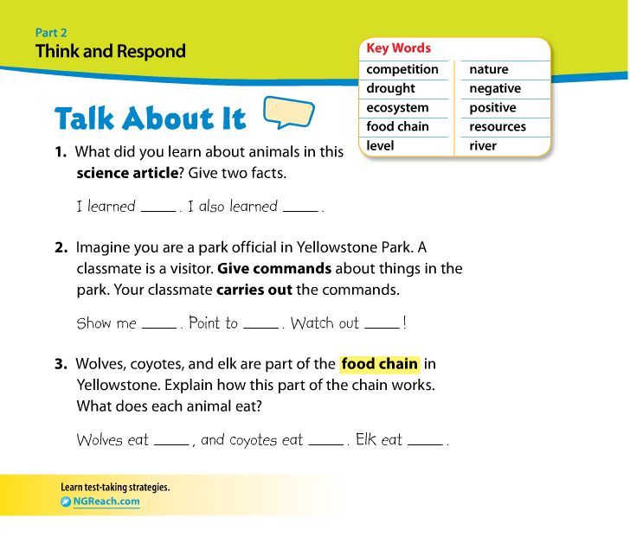

Days 38& 39 - May 14-15, 2020
(2 Day Assignment)
OBJECTIVE: Students practice listening skills.Students will be able to read the text with purpose and understanding, and write information.
SWBAT:
*Use word structure to determine word meaning.
STANDARD(S):
W.4.10. Write routinely over extended time frames (time for research, reflection, metacognition/self-correction and revision) and shorter time frames (a single sitting or a day or two for a range of discipline-specific tasks, purposes, and audiences.
RL.4.10. By the end of the year, read and comprehend literature, including stories, dramas, and poems at grade level text-complexity or above, with scaffolding as needed.
RF.4.4: Read with sufficient accuracy and fluency to support comprehension.
L.4.1: Demonstrate command of the conventions of standard English grammar and usage when writing or speaking.
RL: 5.1, 5.2
RF: 5.3, 5.4
W.5.9
WIDA 1,2, 4: Social & Instructional Language, The Language of Language Arts, The Language of Science
TIME FRAME: 20 minutes
Activity Directions:
Students use YouTube to watch video and take a virtual Field Trip to Yellowstone National Park:https://www.youtube.com/watch?v=2QtdEq2tsh8
Students will explore various animals that live in Yellowstone National Park.

Students will write question:

Would you like to visit Yellowstone National Park & why? Please list your favorite animals & describe them. Please write 2 paragraphs.
Write your answer in your notebook or send a Word document to your ESL teacher in TEAMS.

Learning Materials: Google translate, Reach book

Assessment: WIDA Writing Rubric

